**Modeling Estimating the Potential of COVID-19 Pandemic Spread in Plateau State and Impact of NPI Use**

**Purpose of this memo:** To inform discussions about how to respond to COVID-19 in Plateau State.

**Summary and Recommendations:** We use two models to estimate future pandemic spread in Plateau, both models estimate total infections (detected and undetected). In July: Model 1 estimates ~1,730 (+/- 10% Force of Infection (FoI): ~1,380 – ~2,340) cumulative cases by end of July under continuation of current non-pharmaceutical interventions (NPIs) and ~7,170 (+/- 10% FoI: ~4,000 – ~12,200) prevalence of total infections by the end of the month. Model 2 predicts up to ~32,460 (95% CI: ~4,600 – ~155,000) new infections, assuming a 20% reduction in transmission for 180 days. NPI implementation in Plateau should consider potential risk of underreported cases, concentration of reported cases in Jos, proximity to Abuja and Kano and the need to improve testing. Policymakers should also offer palliatives in areas of lockdown given the state’s large population of informal workers.

**Context:** As of July 12th, Plateau State had 516 confirmed cases and 16 deaths[1]. With the number of confirmed cases continuing to rise, policymakers can consider options to contain pandemic spread and to scale medical response. Furthermore, policymakers may need to consider other factors likely to impact effective NPI implementation (e.g. population density, pandemic spread in neighboring states and proportion of informal workers). In this paper, we present estimated levels of pandemic spread, required hospitalization and ICU capacity, and deaths in the state and discuss considerations to inform pandemic response.

**Caveat – Importance and limitations of testing data:** Testing data provides insights into the current state of the pandemic, helps identify geographies for targeted interventions, and allows for more accurate projections of spread. In Plateau, the positivity rate is ~80%[2], which is higher than the national average of 21%[3] and implies an urgent need to improve testing. It is important to note that this testing limitation introduces a high degree of uncertainty, affects model outputs and underestimates the true extent of spread.

**Modelling methodology:** We use two models to estimate future pandemic spread in Plateau. Model 1 is an SEIR model that predicts the number of detected cases and total infections (detected and undetected) based on historically reported cases, which is dependent on the current testing approach and previous interventions. Model 1 also estimates total deaths based on historical deaths. For Model 1, we show a scenario in which NPIs continue as is. Model 2 is an SEIR model that estimates total infections (detected and undetected) based on historical deaths and previous interventions. For Model 2, we show a scenario where transmission is reduced by 20% for 180 days as a result of NPIs. The range of number of detected cases or infections per month, new cases / infections per month, hospital bed capacity required, ICU bed capacity required and number of deaths July and August 2020 for the scenarios is listed below. Note: for Model 1, hospital bed capacity needed is shown as cumulative numbers of cases requiring hospitalization since the beginning of the epidemic (appendix 1).

**Modelling results for Plateau State**

**Model 1 - “Continuation of current NPIs as is”**

|  |  |  |  |  |  |  |  |
| --- | --- | --- | --- | --- | --- | --- | --- |
| July 2020 | | | | August 2020 | | | |
| Cumulative cases by end of month | Total infections (July 31st ) | Cumulative Hospital bed capacity required | Cumulative deaths by end of month | Cumulative cases by end of month | Total infections (August 31st ) | Cumulative Hospital bed capacity required | Cumulative deaths by end of month |
| 1,200 (+/- 10% FoI: ~1,050 – ~1,450) | 7,170 (+/- 10% FoI: ~4,000 – ~12,200) | 54 (+/- 10% FoI: ~45 – ~65) | 24 (+/- 10% FoI: ~20 – ~30) | 3,750 (+/- 10% FoI: ~2,350 – ~6,500) | 14,700 (+/- 10% FoI: ~6,200 –~33,900) | 169 (+/- 10% FoI: ~105 –~295) | 74 (+/- 10% FoI: ~45 – ~130) |

**Model 2 – 20% reduction in transmission for 180 days scenario**

|  |  |  |  |  |  |  |  |
| --- | --- | --- | --- | --- | --- | --- | --- |
| July 2020 | | | | August 2020 | | | |
| New infections / month | Hospital person-days / month | ICU person-days / month | Number of deaths / month | New infections / month | Hospital person-days / month | ICU person-days / month | Number of deaths /month |
| 32,460 (95% CI: ~4,600 – ~155,000) | 1,746 (95% CI: ~400 – ~6,480) | 252 (95% CI: ~105 - ~660) | ~238 (95% CI: ~9 – ~1,130) | 190,432 (95% CI: ~11,560 – ~862,340) | 8,860 (95% CI: ~885 – ~40,035) | 850 (95% CI: ~180 – ~3,380) | 1,588 (95% CI: ~90 – ~7,440) |

**Implications for pandemic response**

There are a series of NPIs that can be implemented regardless of state-specific circumstances such as risk communication, general hand hygiene, respiratory etiquette, wearing of face masks in public, banning of large public gatherings and physical distancing. There are other NPIs where decisions on whether / how to implement NPIs may vary by state-specific considerations. This state has a number of unique factors that inform implementation of NPIs such as:

* Risk of under-reporting cases: With a ~80% positivity rate compared to a national average of 21%, under-reporting in Plateau is likely due to limited testing capacity. As a result, policy makers can consider increasing testing capacity and ways to deploy existing tests more strategically. Efforts should be made to ensure that all suspected cases are located and tested, and appropriate actions promptly taken for those testing positive.
* Population density: As of June 24th, ~84%[4] of the total confirmed cases in Plateau State had been detected in Jos (North and South) local government, with the remaining cases spread between 5 other local governments. Policymakers should implement a set of NPIs that balance the goal of slowing transmission with potential negative economic and social impacts, which is especially important in dense urban areas such as Jos. Consider NPIs such as general hand hygiene, wearing of face masks in public, and physical distancing as they have relatively limited economic and social impacts, or NPIs such as workplace modifications for non-essential services, as recommended by the WHO[5] and NCDC[6].
* Pandemic spread in neighboring states: Given Plateau’s lower-case count compared to FCT Abuja, Kano and Kaduna, policymakers can consider measures to ensure that individuals coming from these states have been tested for COVID-19 / isolated as needed, and to ensure that they are aware of key NPIs (e.g. handwashing).
* Informal sector workers: Given that informal workers constitute ~40%[7] of Plateau State’s total workforce, policymakers should pay attention to the impact of extended imposition of state border closures or full cessation of movement. Such stringent NPIs could lead to social unrest as these NPIs may prevent informal workers from earning the day to day wages necessary to support themselves and their families. Policymakers can consider different economic and food security aid packages to support informal workers

Given that many states will likely eventually move into widespread transmission, these NPIs may slow transmission or reduce / delay peak number of cases even if they may not reduce overall cases. By slowing transmission, NPIs help buy valuable time for governments to prepare and scale up their medical response (appendix 2).

**Appendix 1: Modelling Methodology**

**Model 1**

We use a compartmental SEIR model to estimate the numbers of infected cases (disaggregated by asymptomatic, symptomatic and notified) and number of deaths in among infectious populations. The model is age-structured and divides the population among the following age groups: 0-14, 15-59 and 60+. This model incorporates case data and deaths data from the NCDC as of June 23, 2020.

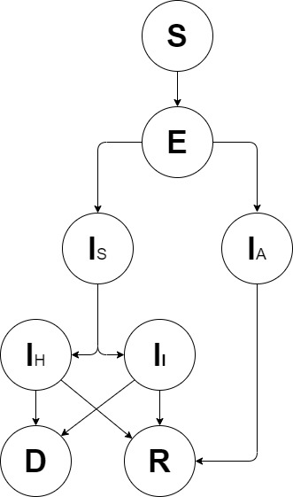

**Model 2**

We use an age-structured SEIR model incorporating explicit passage through healthcare settings and explicit progression through disease severity stages that calibrates itself to death data and previous interventions. This is then used to simulate the impacts of different control interventions (including general social distancing, specific shielding of elderly populations, and more stringent suppression strategies).

By fitting to death data, which is likely more robust than case data (which may be more of a product of the surveillance system than actual transmission), the model seeks to produce an estimate of the true underlying dynamics of infection regardless of surveillance issues related to cases.

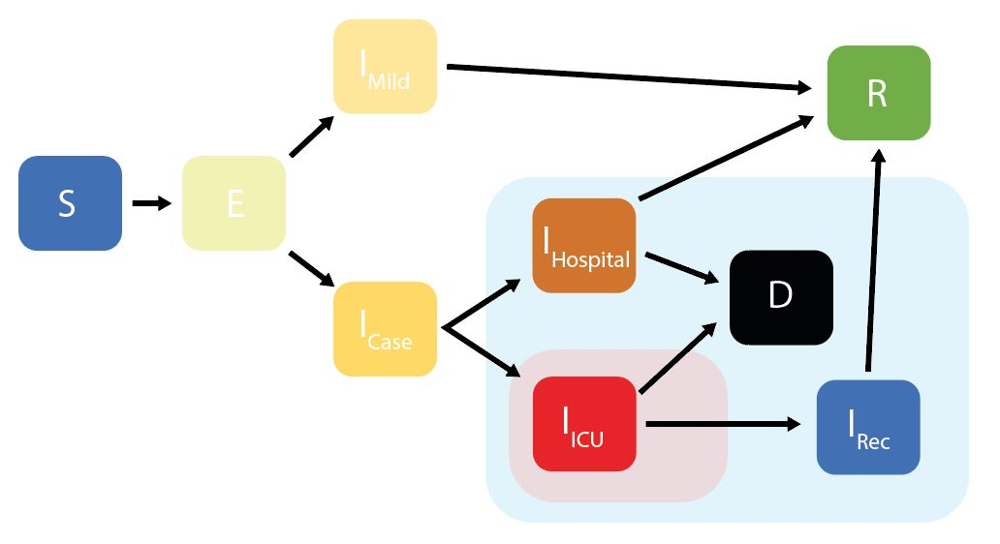

**Appendix 2: Options for medical responses**

* Isolation and supportive care:
  + Hospital and medical facility isolation remain a crucial factor in effective case management with at least 6.8%[8],[9] of patients estimated to require hospitalization. These cases will need to be separated from non-COVID-19 admissions, with appropriate care taken to minimize cross-contact via staff movements.
  + Nigeria’s current isolation and case management capacity has been reported as 5,000 beds as of 19th May 2020[10], but there remains limited information on actual health care staff levels devoted to care of patients in isolation wards. Based on this, a total of ~36,000 confirmed infections needing treatment at the same time could be enough to exceed national isolation supply – this is a conservative estimate, assuming total nationwide capacity is directed at COVID-19 care which is unlikely.
  + While it may be challenging for the federal government to ramp up isolation capacity to meet demand, other contextually relevant countries have leveraged private sector support in attempt to increase capacity.
* Medical oxygen and ventilators:
  + Studies show that medical oxygen therapy is likely to be critical for COVID-19 treatment in severe cases and has a high impact on reduced disease fatality. Furthermore, it is likely to be present long-term benefits to health systems which have long faced systemic shortages in oxygen before the pandemic.
  + Of hospitalized, severe COVID-19 cases, ~85% are estimated to survive with oxygen therapy; without oxygen, a nearly ~100% fatality rate anticipated[11]
  + Medical oxygen therapy requirements include consumables (e.g. nasal cannulas) and monitoring devices, the availability of which may need to be scaled up in Nigeria (CHAI survey Only 55% of Nigerian hospitals provided oxygen therapy) to match potential demand (14% of total COVID-19 infected cases are estimated to require hospitalization and oxygen therapy)[12]
  + Investments to scale up supply must consider critical enablers such as necessary equipment, staff training, and government and private sector support. Delivery modes (e.g. Bulk liquid supply, PSA plants or cylinders) must also be evaluated based on operational feasibility in the Nigerian context and health impact. The Federal Ministry of Health has detailed delivery options in its 2017, 5-year strategy to scale up medical oxygen in health facilities[13]. Given the likely significant surge in demand for medical oxygen due to the COVID-19 pandemic, it may be necessary to expedite some of its delivery initiatives
  + The average cost of oxygen therapy is calculated at between N600 to N7,000 per patient per hour, but in some cases, patients are charged a flat fee per cylinder used[14]. This cost may prove challenging for many Nigerians and may need to be subsidized for most – especially low-income earners in rural regions where supply is likely to be even more strained
  + Scaling up of ventilators not considered here due to the larger cost of acquisition and treatment per patient[15]
* Evidence base for Pharmaceutical Management:
  + Plasmapheresis aims to serve as a prevention and treatment mechanism by transferring plasma from a recovered COVID-19 patient to critically ill COVID-19 patients and those potentially at risk for infection[16]
  + Two studies (sample sizes of 10 severely patients[17] and 5 clinically ill patients[18]) in China have indicated improvement in clinical status of patients after having undergone plasmapheresis. However, further data is needed to confirm the efficacy of this treatment approach
  + As of June 5, no antiviral / antibody treatment is widely available for COVID-19 although human clinical trials are underway and results from many are expected in the summer
    - Remdesivir has been approved for emergency use in the US, UK and Japan, although its efficacy has been shown in clinical trials only for moderately ill persons[19]
    - Preliminary results for favipiravir are mixed with multiple clinical trials expected in July or August[20]
    - Two major trials indicate that hydroxychloroquine is not effective in preventing COVID-19[21] or improving outcome for admitted patients.[22]
    - Initial results suggest promising signs for interferon beta 1b with antivirals (lopinavir–ritonavir, and ribavirin) compared to antivirals alone.[23]
* Evidence base on proportion of symptomatic cases, those in need of hospital care, and those that require critical care:
  + An Imperial College study shows that ~50% - 60%[24] of all cases could be symptomatic cases and that 6.8%[25],[26] of these could require hospitalization. Finally, 30%[27] of hospitalized cases may require critical care.

***The analysis in this paper is purely the work of the Nigeria COVID-19 evidence synthesis group* for use by the PTF. Unauthorized use or publication of this material without the permission of the PTF is prohibited.***

***\* The Nigeria COVID-19 evidence synthesis group is chaired by Prof Ibrahim Abubakar, scientific and technical advisor to the PTF.***

**References**

1. NCDC, “COVID-19 in Nigeria”, <https://covid19.ncdc.gov.ng/>, July 4, 2020
2. NCDC SORMAS Database as of June 10, 2020
3. NCDC SORMAS Database as of June 10, 2020
4. NCDC SORMAS Database as of June 10, 2020
5. WHO, “COVID-19 Strategy Update”, April 14, 2020
6. NCDC, “National Guidelines on Implementing Non-Pharmaceutical Interventions (NPI) – an Adaptive Approach to Targeted Interventions”, May 27, 2020
7. Nigerian Labour Force Statistics, National Bureau of statistics, 2010
8. Imperial, “Impact of NPI reduce COVID-19 mortality and healthcare demand”, <https://www.imperial.ac.uk/media/imperial-college/medicine/sph/ide/gida-fellowships/Imperial-College-COVID19-NPI-modelling-16-03-2020.pdf>), March 16, 2020
9. Population pyramid, “Population Pyramids of the World from 1950 to 2010”, <https://www.populationpyramid.net/nigeria/2019/>, June 11, 2020
10. Business Day Newspaper, 19 May 2020
11. Based on 26 March Imperial College analysis, overall patient progression for African countries, “low peak” scenario with suppression at 0.2 deaths per 100K. Average rate of hospitalization from total infections is 1.8%, with fatality rate based on clinician interviews regarding COVID hospitalization and critical care treatment
12. WHO, “Clinical management of severe acute respiratory infection (SARI) when COVID-19 disease is suspected”, March 12, 2020
13. Nigerian Federal Ministry of Health, “National Strategy for the Scale-up of Medical Oxygen in Health Facilities, 2017-2022”
14. Nigerian Federal Ministry of Health, “NATIONAL STRATEGY FOR THE SCALE-UP OF MEDICAL OXYGEN IN HEALTH FACILITIES, 2017-2022”
15. WHO, “Clinical management of severe acute respiratory infection (SARI) when COVID-19 disease is suspected: Interim Guidance,” March 13, 2020
16. [Transfus Apher Sci](https://www.ncbi.nlm.nih.gov/pmc/articles/PMC7177094/). 2020 Apr 23., 102794.
17. [JAMA.](https://www.ncbi.nlm.nih.gov/pubmed/32219428) March 27, 2020
18. Proceedings of the National Academy of Sciences Apr 2020, 117 (17) 9490-9496
19. Businesswire, “Gilead Announces Results From Phase 3 Trial of Remdesivir in Patients With Moderate COVID-19”, <https://www.businesswire.com/news/home/20200601005310/en/Gilead-Announces-Results-Phase-3-Trial-Remdesivir>, June 1, 2020
20. NYTimes, “Health Coronavirus Glenmark Pharms Study”, <https://www.nytimes.com/reuters/2020/05/26/world/asia/26reuters-health-coronavirus-glenmark-pharms-study.html?searchResultPosition=5>, May 26, 2020
21. Boulware DR, Pullen MF, Bangdiwala AS, et al. A Randomized Trial of Hydroxychloroquine as Postexposure Prophylaxis for Covid-19 [published online ahead of print, 2020 Jun 3]. N Engl J Med. 2020;10.1056/NEJMoa2016638.
22. https://www.recoverytrial.net/news/statement-from-the-chief-investigators-of-the-randomised-evaluation-of-covid-19-therapy-recovery-trial-on-hydroxychloroquine-5-june-2020-no-clinical-benefit-from-use-of-hydroxychloroquine-in-hospitalised-patients-with-covid-19
23. Hung IF, Lung KC, Tso EY, et al. Triple combination of interferon beta-1b, lopinavir-ritonavir, and ribavirin in the treatment of patients admitted to hospital with COVID-19: an open-label, randomised, phase 2 trial. Lancet. 2020;395(10238):1695‐1704.
24. Imperial, “Impact of NPI reduce COVID-19 mortality and healthcare demand”, <https://www.imperial.ac.uk/media/imperial-college/medicine/sph/ide/gida-fellowships/Imperial-College-COVID19-NPI-modelling-16-03-2020.pdf>), March 16, 2020
25. Imperial, “Impact of NPI reduce COVID-19 mortality and healthcare demand”, <https://www.imperial.ac.uk/media/imperial-college/medicine/sph/ide/gida-fellowships/Imperial-College-COVID19-NPI-modelling-16-03-2020.pdf>), March 16, 2020
26. Population pyramid, “Population Pyramids of the World from 1950 to 2010”, <https://www.populationpyramid.net/nigeria/2019/>, June 11, 2020
27. Imperial, “Impact of NPI reduce COVID-19 mortality and healthcare demand”, <https://www.imperial.ac.uk/media/imperial-college/medicine/sph/ide/gida-fellowships/Imperial-College-COVID19-NPI-modelling-16-03-2020.pdf>), March 16, 2020