Position Paper 10: Effect of Interstate Movement Restrictions on COVID-19 Pandemic Spread in Nigeria

May 29, 2020

Purpose of this memo: To inform the discussion of the effect of interstate movement restrictions on COVID-19 pandemic spread in Nigeria

Context: Across the country, Nigerian states have restricted all non-essential forms of movement across their borders, and imposed some intrastate movement restrictions to address pandemic spread. These restrictions have resulted in significant changes in mobility trends, with more people staying at home since the start of the pandemic. Despite these changes, Nigeria has largely moved into widespread community transmission, and policymakers would need to consider whether and how to continue these restrictions, particularly interstate transit restrictions as a strategy to contain further spread given their significant socio-economic implications. To date, there are limited studies on the impact of interstate transit restrictions on the pandemic spread in Nigeria. In this paper, we examine interstate transit restrictions as a possible option to address the pandemic spread in Nigeria.

Summary:
- Models indicate interstate transit restrictions have a small impact on pandemic spread if widespread community transmission exists.
- Important to note to the high degree of uncertainty from these models, and the possible high economic / social costs from of transit restrictions.
- Implementing other interventions that limit contacts between people regardless of state (i.e. intrastate transit restrictions, banning of large public gatherings, etc.) may be more effective in context of widespread community transmission. We consequently recommend only implementing interstate restrictions in very limited contexts and to control very isolated outbreaks, if at all.

Methodologies: We use three complementary methodologies to model the impact of interstate transit restrictions in Nigeria (Appendix 1):
- An agent-based model examines the effects of interstate transit restrictions on pandemic spread in a “virtual space”. This model compares two zones, which can have different parameters that reflect different types of states (e.g., variations in population density, levels of existing infection spread) that share a single border which can be open or partially closed. As discussed in previous papers, this model does not represent a projection of the actual pandemic trajectory in Nigeria or any other country. Rather, it demonstrates the theoretical difference in projected cases under different scenarios in this modeled virtual space.
- Two SEIR models estimate the effect of restricting and opening interstate transit into specific states from the rest of Nigeria. One SEIR model takes a stochastic approach and looks at various types of states based on their level of existing pandemic spread, while the other takes a deterministic approach and specifically assesses the impact of interstate transit restriction on Kano city. While both models do not take into account observed interstate movement patterns derived from sources such as mobile phone data, the deterministic model in Kano utilises data from the National Bureau of Statistics on interstate rail and air. Both model empirical results from different scenarios of changes in interstate mobility going forward. Note that the models do not take into account the potential differential level of response ability and NPI implementation across states.

Modeling results: Overall, our modelling results find the following impacts:
- In a modeled “virtual space” that has two states with community transmission and NPI measures in place, there is a less than 5% change in total cases across the population from implementing interstate transit restrictions under all scenarios except when one state has a high population density and one state has a low population density. In scenarios where one state has high population density and one state has low population density, implementing transit restrictions can lead to approximately 15% reduction in total cases in the state with lower population density but no change or greater cases in the space overall (because more cases cluster in the high population density state). In lower population density states, lowering total symptomatic cases by transit restrictions can lower the peak number of cases and delay spread.
- Estimates for the impact of interstate transit restrictions in Nigeria show very similar results. Our country-wide model finds that in states that have localized community transmission (in the context of Nigeria overall having widespread community transmission), a 90% reduction in the number of people moving in and out of that state could reduce the expected number of symptomatic cases observed in the next six weeks in that state by 50%-80%, but it would have no clear impact on the total number of cases observed in the country overall. On the other hand, in states that already have widespread community transmission, limiting interstate transit has no statistically meaningful impact on the cases observed in that state (and in the country overall). Similarly, our Kano-specific model finds that, over the next two weeks, increasing the number of car trips in and out of Kano city has negligible impact on overall pandemic spread in the state unless the prevalence of COVID-19 among people traveling into the state is several times higher than the current national average. The only scenario where restrictions many impact levels in low incidence areas (up to 2 fold reduction in infections), is if the average national prevalence is 10 times higher than current levels.

When, where, and how other countries have chosen implement interstate transit restrictions (Note – no evidence on the effectiveness)
In general, transit restrictions are likely to be more effective for limiting COVID-19 transmission in the early stages of the pandemic (i.e. before widespread community transmission) where there is a highly localized outbreak that can be rapidly detected (as opposed to situations with widespread community transmission). Nonetheless, other countries that have chosen to impose interstate transit restrictions for different geographies, and typically take a differentiated approach by state in deciding when and where to impose or remove interstate transit restrictions. A differentiated approach requires accurate and timely knowledge of pandemic spread across all states. Examples of transit restrictions include the following:
- India imposed border restrictions on districts depending on a weekly assessment of level of infection spread; districts were initially categorized into red, orange and green zones with different transit restrictions imposed across zones. More recently, new parameters have been issued to categorize areas as ‘critical’ and ‘desirable’. There is currently limited information on measures implemented at each threshold.
- Kenya only imposed interstate transit restrictions on borders of its four main infected areas (i.e., Nairobi, Mombasa, Kilifi and Kwale).
- Benin only implemented intercity transit restrictions around its most affected cities.

Countries without interstate transit restrictions have generally taken steps to build their testing capacities and implement other NPIs. For example:
- Ghana, after the end of their lockdown, removed restrictions on internal transit but imposed other NPIs such as mask wearing and social distancing; the government cited the improvement in testing capacity and the negative economic impact as the most significant considerations
- Mozambique, despite being in a state of emergency, allows interstate land and air transit but banned public gatherings and required mask wearing; the government has stated intent to only impose transit restrictions when there is an exponential increase in cases.
- Angola, which also remains in a state of emergency, has lifted its interprovince transit restrictions partially, allowing for commercial transit for both essential and non-essential businesses while restricting leisure transit.

Appendix 1. Methodology of models and analysis presented
SEIR model
BCG Model: As described in previous position papers on May 5 and May 15, 2020, we use a modified, stochastic, Bayesian SEIR model that accounts for asymptomatic and symptomatic cases among infectious populations. While for previous position papers, we modeled regions with a separated compartment flow, in this position paper, we have added an extension allowing for movement between a specific region and the rest of the country to account for differences in COVID-19 prevalence across the region’s borders (see figure 1). This model incorporates case data from the NCDC as of May 26, 2020 and assumes that lockdown for all regions end on June 1, 2020.

Figure 1: Country-wide modeling
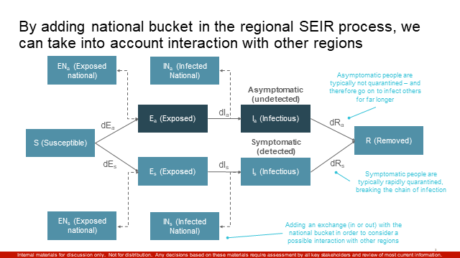

UCL Model: We used a compartmental SEIR model to estimate the number of cases and deaths resulting from infectious people travelling everyday to Kano city either through a car or public transport (see figure 2). The model is age-structured and results include numbers of infected cases (disaggregated by asymptomatic, symptomatic and notified) and number of deaths by age groups: 0-14, 15-59 and 60+. Moreover, the model is designed to specifically analyse the impact of NPI on a metropolitan and district level. In the context of this position paper, Interstate transmission was modelled by inferring the number of infectious people travelling to Kano City by airway, railway and road every day (data from the National Bureau of Statistics) .
Figure 2: Kano city modeling

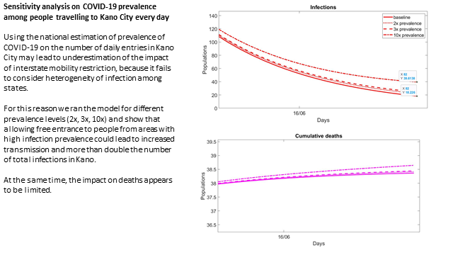
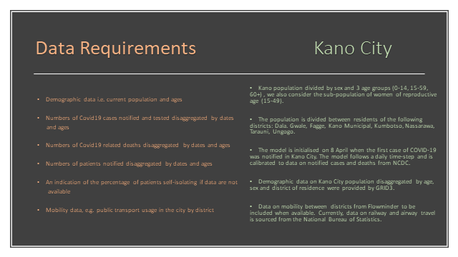

ABM methodology
As described in previous position papers on May 5 and May 15, 2020, we use an agent-based model (ABM) to estimate the impact of different lockdown strategies on pandemic spread at different points in time. This ABM models a virtual “space” in which two zones having different parameters that reflect different types of states (e.g. variations in population density, levels of existing infection spread, baseline level of movement across border, threshold for closing border, % porousness of border when border is closed) share a single border which can be open or partially closed. For example, two zones (Zone A and Zone B – see figure 3) sharing a border may be modeled to be similar in all parameters except population density (i.e., Zone A could reflect a high population density state while Zone B may reflect a low population density state). Although this model has been calibrated with certain other parameters relevant for the Nigerian context (e.g., age distribution of the Nigerian population, average household size, school attendance, part of active population and religious practice), this model does not represent a projection of actual pandemic trajectory in Nigeria or any other country. Rather, it demonstrates the theoretical difference in projected cases under different scenarios in this modeled virtual space.
Figure 3: Virtual space used for ABM
Zone A
Zone B

The analysis in this paper is purely the work of the Nigeria COVID-19 evidence synthesis group* for use by the PTF. Unauthorized use or publication of this material without the permission of the PTF is prohibited.
* The Nigeria COVID-19 evidence synthesis group is chaired by Prof Ibrahim Abubakar, scientific and technical advisor to the PTF.

References

VOA, “Nigerian Governors to Ban Interstate Movement to Contain Coronavirus”, https://www.voanews.com/africa/nigerian-governors-ban-interstate-movement-contain-coronavirus, April 23, 2020
Pandemic International, “Travel restrictions, flight operations and screening”, https://pandemic.internationalsos.com/2019-ncov/ncov-travel-restrictions-flight-operations-and-screening, May 28, 2020
Google, “Nigeria COVID-19 Community Mobility Report”, May 16, 2020, https://www.gstatic.com/covid19/mobility/2020-05-16_NG_Mobility_Report_en.pdf
Sahara Reporters, “Nigeria At Community Transmission Phase Of COVID-19, Lockdown, Curfew Violations Dangerous”, http://saharareporters.com/2020/05/08/nigeria-community-transmission-phase-covid-19-lockdown-curfew-violations-dangerous-%E2%80%94boss, May 8, 2020
These general findings have also been validated by independent analysis by colleagues from Flowminder
Source: Boston Consulting Group SEIR model
Source: UCL SEIR model
Jagran, “Lockdown 3.0: Complete list of new guidelines for next two weeks from May 4, here's what's allowed and what's not”, https://english.jagran.com/india/lockdown-extension-two-weeks-may-4-may-17-restrictions-public-transport-schools-liquor-shops-red-orange-green-zones-home-ministry-delhi-uttar-pradesh-maharashtra-10011369, May 3, 2020
“Centre lists parameters for states to mark zones,” Times of India May 18, 2020, https://timesofindia.indiatimes.com/india/lockdown-4-0-centre-lists-parameters-for-states-to-delineate-red-orange-green-zones/articleshow/75795011.cms
Aljazeera, “Kenya bans travel in and out of Nairobi, other areas”, https://www.aljazeera.com/news/2020/04/covid-19-kenya-bans-travel-nairobi-areas-200406163601579.html, April 6, 2020
Garda, “Benin: Authorities enact restrictive measures due to COVID-19 /update 1”, https://www.garda.com/crisis24/news-alerts/326306/benin-authorities-enact-restrictive-measures-due-to-covid-19-update-1, March 25, 2020
CNN, “Ghana lifts lockdown, citing improved testing and 'severe' impact on the poor”, https://edition.cnn.com/2020/04/20/africa/ghana-ends-lockdown-intl/index.html, April 20, 2020
Pandemic International, “Travel restrictions, flight operations and screening”, https://pandemic.internationalsos.com/2019-ncov/ncov-travel-restrictions-flight-operations-and-screening, May 28, 2020
Pandemic International, “Travel restrictions, flight operations and screening”, https://pandemic.internationalsos.com/2019-ncov/ncov-travel-restrictions-flight-operations-and-screening, May 28, 2020

