Position Paper 11: Effect of COVID-19 and Response Measures on Population Health and Socio-economic Well-being

June 12, 2020
Purpose: To inform consideration of the effect of COVID-19 and response measures on population health and socio-economic well-being

Context: Previous outbreaks such as Ebola in West Africa and SARS in East Asia had outsized effects on wider population health and well-being through secondary effects on healthcare seeking behaviour, reductions in health systems functioning, and social and economic disruptions. The extent of the COVID-19 epidemic in Nigeria and impact of response measures in Nigeria will determine the full health effects of the pandemic.

Summary and Recommendations
- There is strong evidence of disruption to health services due COVID-19 control measures in Nigeria. Model projections for maternal and child health, including immunisation, as well as tuberculosis, HIV and malaria predict a high death toll if specific countermeasures are not taken. Action is needed to maintain provision of essential services to prevent a large number of avoidable deaths, with a focus on areas undertaking precision lockdown.
- Poor people are least able to protect themselves from COVID-19 due to inability to practice social distancing; they are also experiencing significant economic hardship from lockdowns. Data from the National Longitudinal Survey and the COVID-19 tracker survey provide strong evidence on lockdowns’ impact on financial and food security.
- COVID-19 response measures will worsen Nigeria’s already excessive inequalities unless specific measures are taken. Government interventions should proactively target vulnerable population groups in LGAs subject to precision lockdown, and include measures to improve financial and food security, engage local leaders, secure community buy-in, and support people in urban slums and IDP camps.

Wider Impact of COVID-19 on population health
General Health Access: NHMIS service utilization data (drawing on DHIS2) shows significantly decreased utilization of basic services (outpatient attendance, inpatient admissions antenatal care, oral polio vaccine) compared to the same period in 2019 at national level and in certain states, with >50% reductions in Lagos state (Appendix 1). A survey of 4,202 Nigerians (late April/early May) by Covid19tracker.africa found high levels (>50%) of awareness of the need to stay home, with data up to 8th May showing 3% had a change in access to chronic care and up to 14% had difficulties accessing medicines.

Maternal and Child Health: The LIST model estimates that if coverage of maternal and child health services in Nigeria were reduced by 15% for 6 months due to COVID-19, this would result in additional deaths, and a 45% reduction for 6 months would result in considerably more deaths (detailed numbers of deaths in women and children by intervention are summarised in Appendix 2). Regarding immunisation, models from the Vaccine Impact Consortium concluded that the benefits of routine immunisation outweigh the risks of excess COVID-19 deaths due to transmission attributable to immunisation visits by 116:1 in Nigeria. Previous disruptions to measles vaccination are illustrative. In 2019, Kogi and Niger States missed the 2019 supplementary immunisation activity, projected to lead to a >10-fold projected increase in measles cases in 2020. COVID-19 has led to delays and cancellation of planned bivalent OPV and monovalent OPV2 outbreak response activities, which can decrease serotype-specific immunity, with high risks for Nigeria’s polio status.

TB/HIV/malaria: Modelling by the Malaria Atlas Project suggests that a disruption to malaria services starting 1st May and continuing for 6 months could affect access to care and treatment for 80% of malaria cases this year, leading to up to 100,000 additional malaria deaths. Imperial College models also found a high burden of additional malaria deaths under various scenarios, with disruption of treatment and prevention services depending on the overlap between COVID-19 disruptions and the malaria seasons. For tuberculosis, while there no Nigeria-specific analysis yet, models in Africa suggest a 2-month lockdown will lead to a 1-2% increase in TB deaths. The impact of COVID-19 on the HIV epidemic will depend on whether the continuity of supply of anti-retrovirals (ARV) is maintained. If supply is disrupted, and assuming no change in sexual behaviour, multiple mathematical models suggest thousands of excess HIV deaths in the next 12 months. NACA confirm that adequate supply of ARV was provided to persons living with HIV, however, a Finmark Survey suggests general disruption to health care access and medicines.

Impact on poverty & inequalities
Poor people in Nigeria will suffer disproportionately from COVID-19 due to lesser ability to engage in mitigation measures such as social distancing and the economic effects of response measures such as lockdowns. Nigeria began this pandemic with a large vulnerable population: 90 million Nigerians live in extreme poverty on less than US$1.90/day and 1 in 5 are unemployed, with areas of concentrated vulnerability in urban slums and IDP camps in the North East. A national representative survey undertaken by the National Bureau of Statistics and the World Bank in April/May 2020 (National Longitudinal Phone Survey, n=1,950 households) found that >90% of Nigerians were worried about their finances. 42% of respondents who were working before the outbreak said they were not currently working due to COVID-19, especially in the commercial sector, with 79% reporting a decrease in income since March. The survey found high levels of economic shock compared to the past 3 years with 35-59% reporting difficulties affording staple foods.

Covid19tracker.africa survey provides additional data, covering all geopolitical zones (n=4,202). Over 80% of respondents were unable to come up with emergency funds (1/20th of GNI per capita in 7 days) and 6% reported recent borrowing; at the same time the proportion reporting difficulty accessing government support decreased from 46% to 19% between mid-April and early May. Reported monthly income increased by an average of 1000 Naira in May compared to April but levels were below last year by comparison. The survey reported that lack of food availability and number of skipped meals declined between April and May.

Nonetheless the pandemic and mitigation measures could have long-term social and economic effects. Only 62% of respondents in the NBS/WB survey said their children had engaged in any learning/educational activities since the closures began. In past epidemics, girls were more likely to drop out of school, worsening gender inequalities. A DFID-funded survey of 653 business firms in Kano, Kaduna and Jigawa, about 30% of the workforce might have been laid off due to Covid-19, with 11% of firms selling assets (Appendix 3).

Targeting by geographic area and population risk group
Vulnerability varies between and within regions (Appendix 4), and within populations, with women, disabled people, the elderly, and other groups experiencing specific negative effects. Future analyses to mitigate the socio-economic impact could use risk stratification to target the most disruptive NPIs (e.g. lockdowns) geographically, as well as apply dedicated policy instruments to ameliorate conditions for the specific vulnerable groups. In terms of food security, supply chains for humanitarian services must be assured (e.g. in IDP camps in the North East), with additional food support for urban poor populations affected by lockdowns. Future analyses are forthcoming to identify geographic zones and population groups at highest need of socioeconomic support.
Appendix 1. Health service utilization during the COVID-19 pandemic (NHMIS data drawing from DHIS2, available on FMOH website)
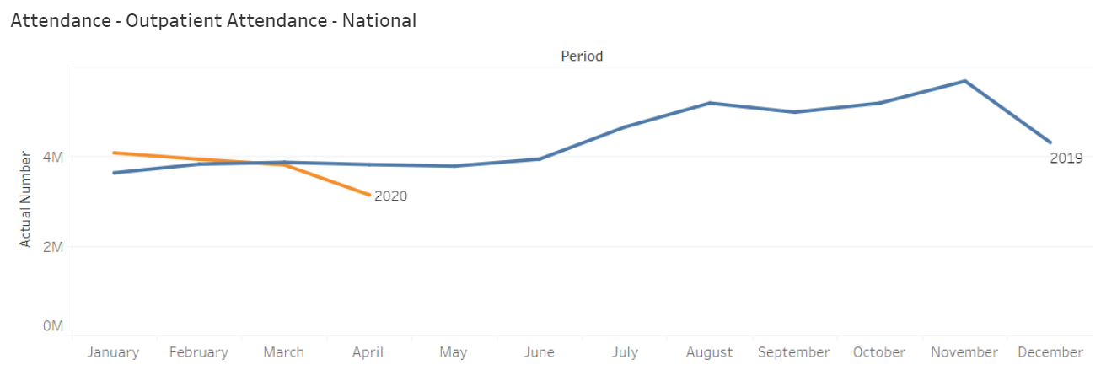
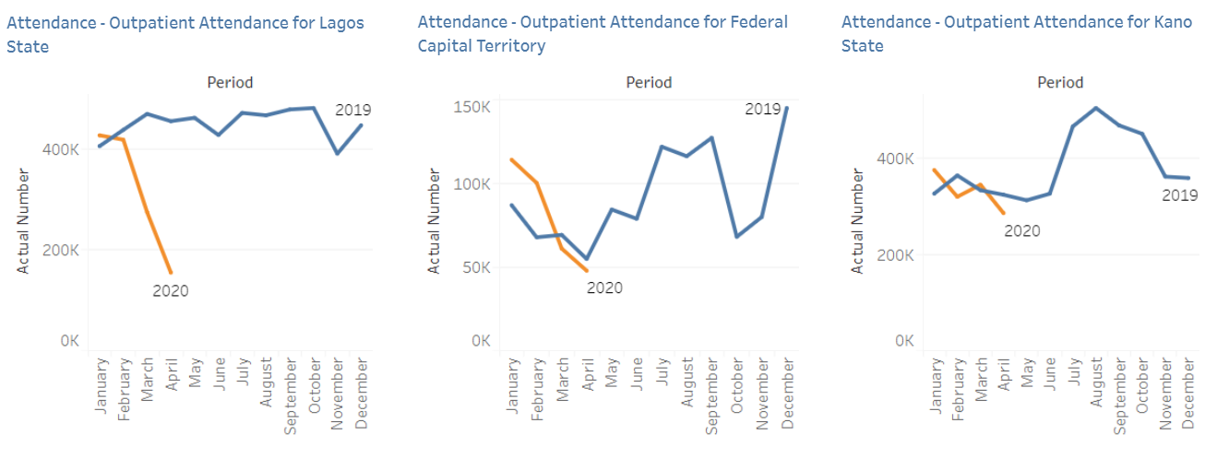
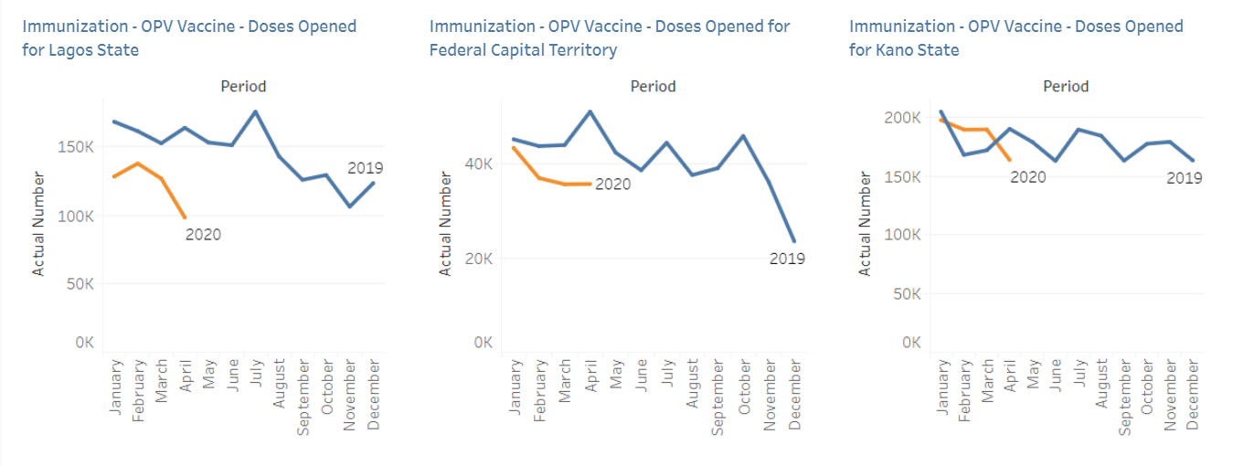
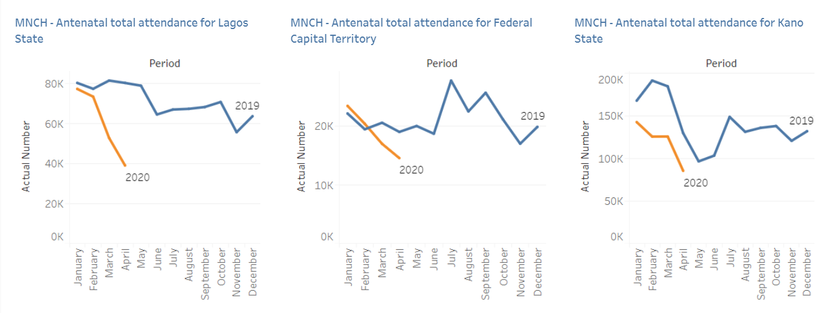
Last data update: 5 June 2020

Appendix 2: Maternal and child deaths by intervention at 12, 6 and 3 months from COVID-19 disruption in Nigeria (LIST Model)

 | 12 MONTHS | 6 MONTHS | 3 MONTHS
Intervention | Maternal deaths due to decrease
Contraceptive use | 381 | 191 | 95
TT - Tetanus toxoid vaccination | 20 | 10 | 5
IPTp - Intermittent preventive treatment of malaria during pregnancy | 155 | 77 | 39
Micronutrient supplementation (iron and multiple micronutrients) | 193 | 97 | 48
Hypertensive disorder case management | 168 | 84 | 42
Malaria case management | 87 | 44 | 22
MgSO4 management of pre-eclampsia | 435 | 218 | 109
Clean birth environment | 271 | 135 | 68
Antibiotics for preterm or prolonged PROM | 115 | 57 | 29
Parenteral administration of anti-convulsants | 375 | 187 | 94
Parenteral administration of uterotonics | 628 | 314 | 157
Parenteral administration of antibiotics | 348 | 174 | 87
Assisted vaginal delivery | 35 | 18 | 9
Manual removal of placenta | 77 | 39 | 19
Removal of retained products of conception | 68 | 34 | 17
Caesarean delivery | 34 | 17 | 9
Blood transfusion | 59 | 30 | 15
ITN/IRS - Households protected from malaria | 163 | 82 | 41
Intervention | Child deaths due to decrease
TT - Tetanus toxoid vaccination | 1,531 | 765 | 383
IPTp - Intermittent preventive treatment of malaria during pregnancy | 370 | 185 | 93
Syphilis detection and treatment | 22 | 11 | 6
Maternal age and birth order | 16 | 8 | 4
Thermal protection | 1,303 | 651 | 326
Clean cord care | 1,202 | 601 | 301
Clean birth environment | 694 | 347 | 174
Immediate drying and additional stimulation | 965 | 483 | 241
Neonatal resuscitation | 1,191 | 595 | 298
Antibiotics for preterm or prolonged PROM | 292 | 146 | 73
Parenteral administration of antibiotics | 292 | 146 | 73
Assisted vaginal delivery | 544 | 272 | 136
Caesarean delivery | 203 | 101 | 51
Vitamin A supplementation | 3,527 | 1,764 | 882
ITN/IRS - Households protected from malaria | 402 | 201 | 100
Complementary feeding (via reduction in stunting) | 263 | 132 | 66
DPT vaccine | 913 | 456 | 228
H. influenzae b vaccine | 924 | 462 | 231
Pneumococcal vaccine | 939 | 470 | 235
Measles vaccine | 429 | 214 | 107
Case management of neonatal sepsis/pneumonia | 4,243 | 2,122 | 1,061
ORS - oral rehydration solution | 8,178 | 4,089 | 2,044
Antibiotics for treatment of dysentery | 947 | 473 | 237
Zinc for treatment of diarrhoea | 1,209 | 604 | 302
Oral antibiotics for pneumonia | 25,324 | 12,662 | 6,331
Vitamin A for treatment of measles | 2,522 | 1,261 | 630
ACTs- Artemisinin compounds for treatment of malaria | 792 | 396 | 198
Change in wasting prevalence | 20,545 | 10,272 | 5,136

Appendix 3. Selected findings from a DFID-funded survey
Table 1. Jobs lost per sector (Businesses employed a total of 3,858 staff before lockdown; 28% of employees lost their jobs due to Covid-19)
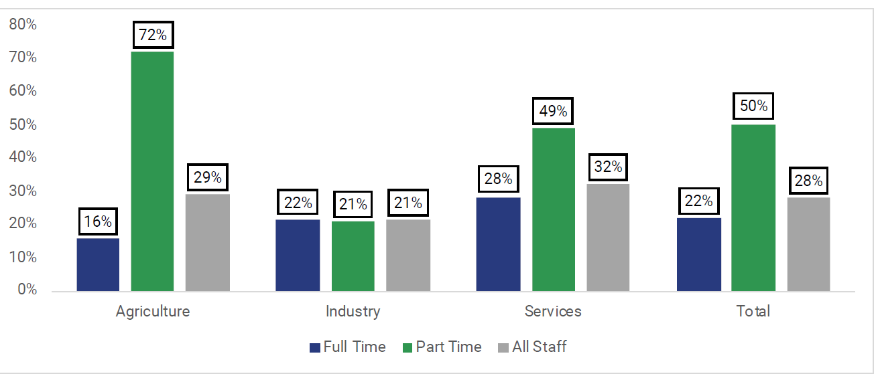

Table 2. Reported changes in revenue across businesses (83% of businesses reported decreases in revenue)
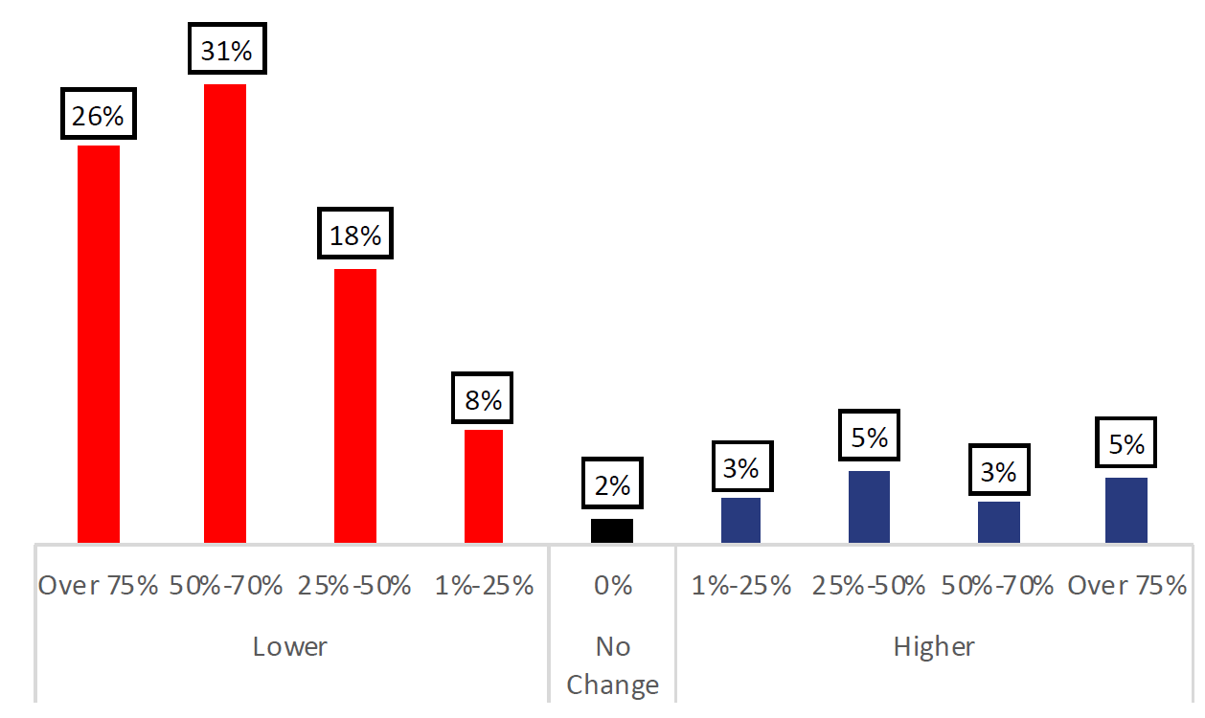

Table 3. Businesses cope by reducing salaries, deferring loans, and selling assets
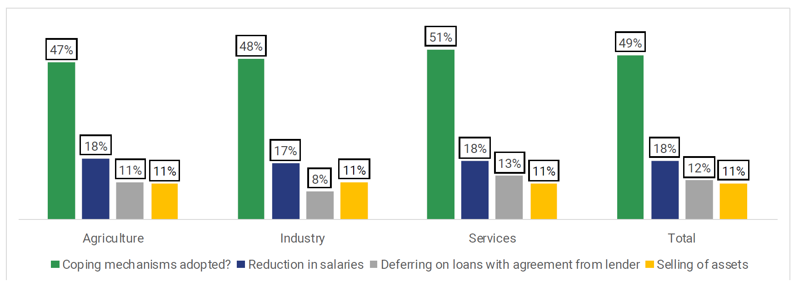
Appendix 4. Geographical risk profiles (GRID3 and FRAYM)
The socio-economic profile is an index of socio-economic vulnerability to COVID-19, highlighting poor populations with limited options to cope with economic shocks, developed with a list of indicators of socio-economic status from Demographic and Health Survey (DHS) 2018 and General Household Survey (GHS) 2016.
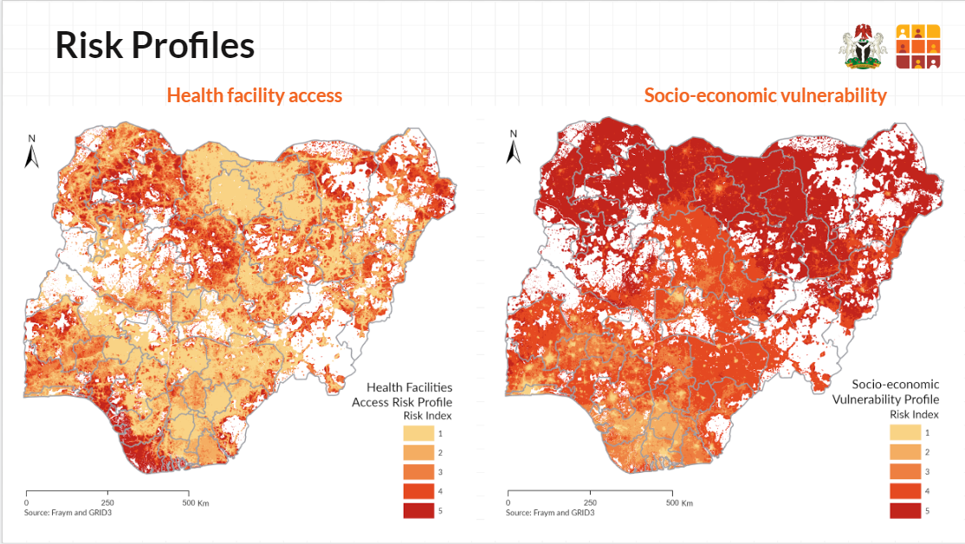
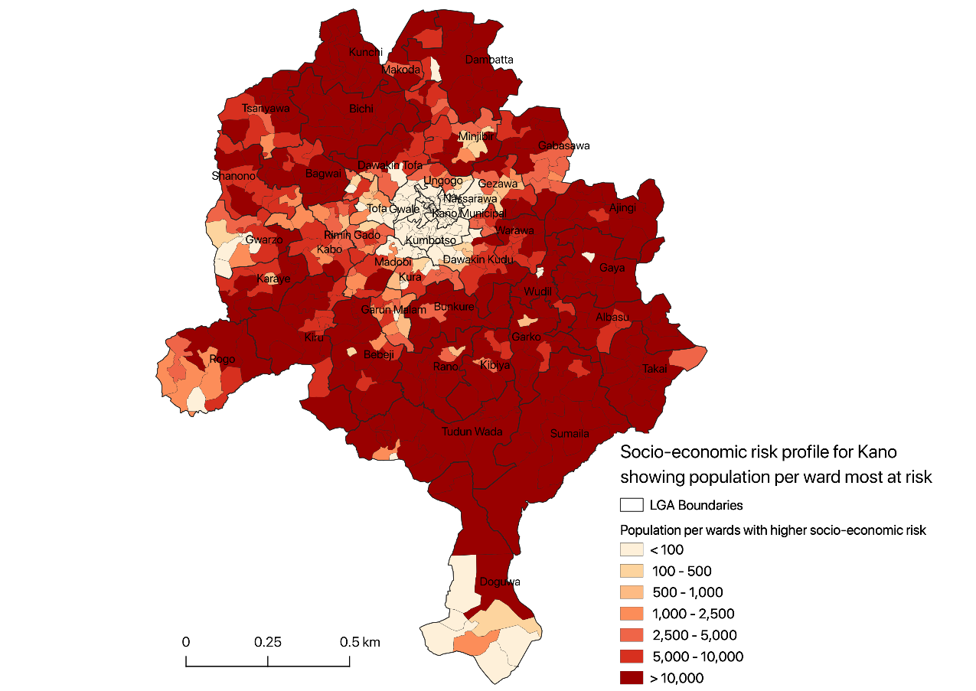

The analysis in this paper is purely the work of the Nigeria COVID-19 evidence synthesis group* for use by the PTF. Unauthorized use or publication of this material without the permission of the PTF is prohibited.
* The Nigeria COVID-19 evidence synthesis group is chaired by Prof Ibrahim Abubakar, scientific and technical advisor to the PTF.

References

Report 19 Imperial College London https://www.imperial.ac.uk/media/imperial-college/medicine/mrc-gida/2020-05-01-COVID19-Report-18.pdf
http://www.stoptb.org/assets/documents/news/Modeling%20Report_1%20May%202020_FINAL.pdf
Potential effects of disruption to HIV programmes in sub-Saharan Africa caused by COVID-19: results from multiple mathematical models. Lancet HIV
https://covid19tracker.africa/widget/NGA/change-in-chronic-care? and https://covid19tracker.africa/widget/NGA/access-to-medicine?
World Bank Poverty and Equity Data Portal
National Bureau of Statistics. Labour Force Statistics, Q4 2018.
Bandiera O, Buehren N, Goldstein M, Rasul I, Smurray A. The Economic Lives of Young Women in the Time of Ebola: Lessons from an Empowerment Program. Washington, DC: World Bank Group, 2018
UNDP, The Covid-19 Pandemic in Nigeria: Potential impact of lockdown policies on poverty and well-being - Brief 3 (21 April 2020), https://www.ng.undp.org/content/nigeria/en/home/library/the-covid-19-pandemic-in-nigeria--potential-impact-of-lockdown-p.html

