Position Paper on COVID Response – April 23, 2020

Interventions to support post lockdown measures

Table of contents

1 Purpose of memo 3
2 Methodology: 3
2.1 Country case studies 3
2.2 Assessment of NPIs in Nigerian context (health 3
3 Results 4
Table 1. “Upper bound” and “lower bound” scenario impacts 4
Table 2. Scenario impacts 5
Figure 1. Ranking of NPIs by feasibility and impact 6
4 Discussion of findings and implications 6
5 Future directions for research 8
Deep-dive 1. Quantitative modeling methodology 9
Deep-dive 1.1 Health impact modeling 9
Deep-dive 1.2 Additional detail on SEIR modeling results 11
Deep-dive 1.3 Wage loss and food security impact methodology 15
Deep-dive 2. Operationalization of testing, tracing, and isolation 16
Deep-dive 3. Feasibility and operationalization considerations for select NPIs 18
Deep-dive 4. Country case studies 21
Deep-dive 4.1 Case study on Ghana 21
Deep-dive 4.2 Case study on India 22
Deep-dive 4.3 Detailed table of country case studies (as of April 15th) 23

Purpose of memo
Around the world, countries have implemented lockdowns to limit pandemic spread. Given that it is likely not feasible to maintain a lockdown until a vaccine is developed, governments will have to eventually consider other approaches to addressing the pandemic. The purpose of this paper is to present ideas of NPIs to put in place if and when a lockdown is lifted in Nigeria. These NPIs are considered from the perspective of potential health impact, wage loss and food insecurity impact, and operational feasibility.

Methodology:

Country case studies
We developed two sets of country case studies to build an understanding of how countries around the world are approaching this challenge:
- Specific deep-dives on Ghana and India as examples of how countries have bundled different NPIs into strategies (see Deep-dive 4.1 and Deep-dive 4.2)
- Detailed country case studies of when, how, and with what impact countries have begun to ease lockdown (see Deep-dive 4.3)

Assessment of NPIs in Nigerian context
We then assessed the potential health impact, wage loss and food security impact, and feasibility of select NPIs in the Nigerian context:

Health impact
We used a modified, stochastic, and Bayesian SEIR model, accounting for asymptomatic and symptomatic cases among infectious populations. We assume homogeneous mixing of the population. The reproduction rate (R-t) of transmission varies as a function of population density, cultural interaction patterns, etc. R-t varies over time and is responsive to government non-pharmaceutical interventions (NPIs) to control pandemic spread. Using this model, we assessed the impact of each NPI on total symptomatic cases, in comparison with an “upper bound” scenario that accounts for lockdown until April 27, followed by no specific intervention other than some social distancing and limited public information campaigns. We used global benchmarks from the Oxford Stringency Index to quantify the amount of pressure put on the social context of human interaction by each NPI. We then scaled this index value by a factor that takes into account Nigerian data on NPI implementation, in order to align these global benchmarks to the Nigerian context. Future iterations of our model will evolve to incorporate more specific Nigerian data and tailor even more closely to the Nigerian context (see Deep-dive 1.1 for more details on the methodology used).

Using this approach, we modeled the following scenarios:
  - “Upper bound” of cases: Lockdown remains in place through April 27 and is then followed only by limited social distancing and public information campaigns
  - “Lower bound” of cases: Full lockdown remains in place for four months
  - 4 NPI scenarios to assess the impact of discrete NPIs – school closings, ban on group gatherings, wearing of face coverings, intensification of public information campaign
  - Combination of above 4 NPIs
  - Note that the “upper bound” and “lower bound” scenarios represent extreme cases of how the government could choose to respond to the pandemic, and they do not represent a recommended course of action. Rather, they are intended to provide a range of the total possible cases that could be observed in the coming months under different scenarios. As noted in the methodology section, this model currently does not necessarily reflect the level of herd immunity that would be achieved when accounting for heterogeneity of population mixing.

Wage loss and food security impact
Using high-level economic data and the median number of symptomatic cases from the SEIR model, we developed directional, static estimates of potential ranges of people impacted by wage loss and food insecurity. These numbers provide a snapshot in time and do not incorporate computational general equilibrium modeling or secondary economic impacts. Moreover, the food security analysis shown does not include any impacts on production, supply chain, global or local food prices. This analysis is intended to be directional only and is in no way a comprehensive picture of economic impact. Future iterations of analysis will leverage computational general equilibrium modeling to assess the impact of various health interventions, including different durations of lockdown, on key macroeconomic indicators (e.g., GDP, trade balance), as a further input into the consideration of different health interventions. Methods are summarized below, with full methods available in Deep-dive 1.3.
  - Impact of wage earner illness: We assume that households will be economically impacted when earners fall ill, assuming an even distribution of symptomatic cases across the workforce. A range of potential impacts is calculated assuming an impact on self-employed workers only (lower end of range) to inclusive of all types of workers (upper end of range).
  - Impact of business closure under continued lockdown: We estimate the impact of closure of “non-essential” businesses, assuming self-employed workers will be most heavily impacted. A range of potential impact is calculated assuming an impact on self-employed workers in “non-essential” businesses only (lower end of range) to all self-employed workers excluding agriculture (upper end of range).
  - Impact on food security: We estimate the number of people who will shift from "borderline" to "poor" food consumption, assuming that people with “borderline” food consumption before the pandemic are at risk of poor food consumption if they are unable to work due to business closure or illness. A range of potential impact is calculated assuming an impact on individuals in the bottom three income quintiles only (lower end of range) to all income quintiles (upper end of range). For the lockdown scenario, food security impact also includes people with a borderline food consumption score who are self-employed (ranging from impact on non-essential only to essential). All estimates include both the worker and their assumed dependents.

Feasibility of NPIs
We evaluated each NPI as high, medium, or low, based on the average score across three qualitative criteria: enforcement needs and likelihood of compliance, resources required (human and supplies) and operations, and societal constraints. See endnotes for detailed definitions of ratings for each dimension. Then using country benchmarks, we defined a list of operational considerations to implement each NPI in the Nigerian context. We then used examples from contextually-relevant countries as benchmarks and developed a detailed set of operational implications for Nigeria, as described in Deep-dive 3.

Results
Once there is widespread community transmission, many countries, including Nigeria, implemented a lockdown in order to reduce transmission. However, lockdowns have significant impacts on the economy and food security and will likely need to be lifted before a vaccine for COVID is available. When case count is low, lab-based testing, tracing, and isolation of cases is an important and feasible strategy to address both symptomatic and asymptomatic transmission. However, benchmarks from other countries indicate that this is a highly operationally intense activity, and therefore is likely to be infeasible as the sole strategy to address pandemic spread once there is widespread community transmission. See Deep-dive 2 for more details on operational requirements for this strategy.

Therefore, we have modeled scenarios for future courses of action, including: “upper bound” of cases (limited NPIs post-lockdown), “lower bound” (full national lockdown continues for several months), and various NPIs. The results of these scenarios, including health impact, economic and food security impact, and feasibility of the scenarios, are summarized below and in Table 1 and Figure 1. See Deep-dive 1.2 Deep-dive 2 for further details. Note that any and all NPIs should also be complemented by increases in handwashing, respiratory hygiene, and other similar recommended practices.

All scenarios assume a theoretical maximum of implementation effectiveness, based on a set of benchmark countries. This level of implementation effectiveness would likely be challenging to achieve, especially social distancing within workplaces. Prior evidence on impact of NPIs is based on levels of effectiveness generally observed within lockdown context, thus impact is likely to be lower if lockdown not in place. This caveat is particularly important for the “combination of NPIs” scenario. The modeled figures are based on best data available at the time of writing, and are not intended to represent definitive projections of the course of the pandemic.

The range of total cases modeled by our preliminary SEIR over the next one month is summarized for each scenario directly below.
- “Upper bound”: 144,000 (80% CI: 7,000 – 17,592,000)
- “Lower bound”: 4,000 (80% CI: 2,000 – 52,000)
- School closings: 21,000 (80% CI: 3,000 – 1,488,000)
- Ban on group gatherings: 80,000 (80% CI: 5,000 – 10,005,000)
- Wearing of face coverings: 38,000 (80% CI: 4,000 – 3,779,000)
- Intensification of public information campaigns: 57,000 (80% CI: 4,000 – 6,670,000)
- Combination of 3, 4, 5, and 6: 5,000 (80% CI: 2,000 – 62,000); This scenario is highly dependent on the effectiveness of implementing NPIs

- “Upper bound” and “lower bound” scenario impacts
 | Health Impact  Number of total cumulative cases after 1 and 4 months | Wage Loss impact  Number of people and dependents affected by work loss due to illness or business closure after 1 and 4 months | Food security impact  Number of people at risk of shifting from “borderline” food consumption to “poor” food consumption after 1 and 4 months | Relative feasibility
“Upper bound” – Lockdown ends on April 27, limited NPIs in place | 1 month: 144,000 (80% CI: 7,000 – 17,592,000)  months:  43,517,000 (80% CI: 257,000 - 105,704,000) | 1 month: 1-2M people  4 months: 70-110M people | 1 month: 16-26k people  4 months: ~5-8M people | High  - Relatively limited enforcement, resources and societal constraints required to implement limited NPIs (e.g., suggested social distancing)
“Lower bound” – Full Lockdown continues for 4 months | 1 month: 4,000 (80% CI: 2,000 – 52,000)  4 months: 18,000 (80% CI: 2,000 - 34,768,000) | 1 month: 40-75M people  4 months: 40-75M people | 1 month: ~5-10M people  4 months: ~5-10M people  + 9.9M children lose access to school feeding programs | Low  - Mass implementation makes easier to enforce compared to targeted lockdowns, but still difficult overall, especially over time  - May need to set up resource delivery services in certain areas  - High economic and societal constraints given very large interference in day to day life

- Scenario impacts
 | Health Impact  % lower in total cumulative cases relative to “upper bound” and % higher relative to “lower bound” after 1 and 4 months in median scenario | Wage Loss impact  Number of people and dependents affected by work loss due to illness or business closure after 1 and 4 months | Food security impact  Number of people at risk of shifting from “borderline” food consumption to “poor” food consumption after 1 and 4 months | Relative feasibility
School closings | 1 month:  - Up to 85% lower”  - 390% higher  4 months:  - Up to 72% lower  - 68,500% higher | 1 month: 0.2-0.3M people  4 months: 12-19M people | 1 month: ~2-4k people  4 months: ~1-2M people  + 9.9M children lose access to school feeding programs | High  - Likely relatively high ease of enforcement  - Relatively limited resources required to close schools  - Ramp up of resources required to successfully execute remote learning and continue school feeding programs over time
Ban on group gatherings (e.g. celebratory events, religious worship, meetings of people in workplaces and markets) | 1 month:  - Up to 45% lower  - 1,700% higher  months:  - Up to 14% lower  - 210,700% higher | 1 month: 0.8-1M people  4 months: 50-75M people | 1 month: ~9-15k people  4 months: ~4-7M people | Medium  - Likely low levels of uptake without enforcement (e.g. fines)  - Moderate ramp up of human resources  - Societal constraints to achieve compliance in settings such as workplaces / offices, open-air markets, bus depots, and other points of convening
Wearing of face coverings | 1 month:  - Up to 74% lower  - 800% higher  4 months:  - Up to 41% lower  - 143,400% higher | 1 month: 0.4-0.6M people  4 months: 27-40M people | 1 month: ~4-7k people  4 months: ~3-4.6M people | Medium  - Likely low levels of uptake without significant enforcement or change of social norms  - Limited supply of masks & difficulty distributing to everyone who needs one  - Relatively low cost to individual but could require extensive budget to produce/distribute
Public information campaigns (e.g. campaigns to increase handwashing, respiratory hygiene, social distancing) | 1 month:  - Up to 61% lower  - 1200% higher  4 months:  - Up to 25% lower  - 183,800% higher | 1 month: 0.6-0.8M people  4 months: 40-60M people | 1 month: ~6-10k people  4 months: ~3.5-6M people | High  - Relatively limited enforcement, resources and societal constraints required to implement public information campaigns
Combined implementation of the above 4 scenarios | 1 month:  - Up to 97% lower  - 8% higher  4 months:  - Up to 99% lower  - 39% higher | 1 month: 40-65k people  4 months: 170-250k people | 1 month: Up to 1k people  4 months: 3-5k people | Medium  - Some enforcement required  - Moderate ramp up of human resource  - Likely limited societal constraints

- Ranking of NPIs by feasibility and impact
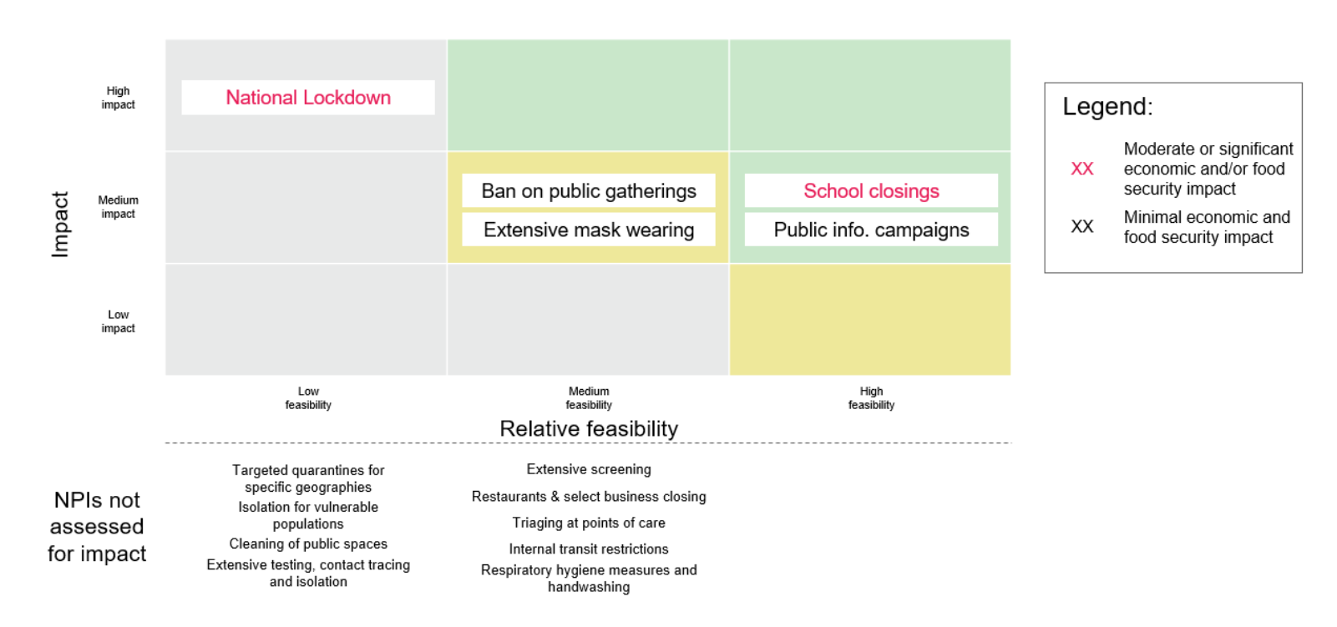

Discussion of findings and implications
Countries have taken a wide array of approaches in terms of NPI selection post-lockdown (See Deep-dive 4.3). Any NPI strategy necessitates trade-offs between immediate health outcomes and other socio-economic factors (that may themselves have long-term health impacts). NPIs highlighted in green and yellow above represent those that may be considered feasible to implement when lockdown ends or shortly thereafter, with varying degrees of impact. NPIs that are more complex to operationalize can be evaluated further for future implementation (see Deep-dive 3 for more details on specific operational considerations for select NPIs). Any and all NPIs should also be complemented by increases in handwashing, respiratory hygiene, and other similar recommended practices. Moreover, as the government eases lockdown restrictions in favor of a set of less restrictive NPIs, there are several additional actions it could consider supporting the economy and society through this transition.

Some countries have chosen to shift from lockdown to a more limited set of NPIs at a national level, with no or very limited lockdown at sub-national level. There are two reasons a government might choose to do this: (1) pandemic risk is relatively uniform across a nation, and can be managed within the existing healthcare infrastructure; or (2) it is infeasible to lift the lockdown in some geographies and not others (either due to insufficient capacity to limit internal movement across geographic quarantine lines, or political infeasibility of treating different areas differently). For example, Ghana, after ending its lockdown, took the approach of instituting a series of additional NPIs including school closures, banning public gatherings, social distancing, limitations on market openings, mandated use of masks for certain servicepeople (e.g., barbers, tailors, shop keepers, etc.), and border closures. Businesses were also required to achieve social distancing and hygiene protocols in order to continue operation (see Deep-dive 4.1 for more detail).

Other countries comprised of states with diverse economies and demographics, such as India, have developed pandemic response strategies that allow for differentiated responses in different areas. While India initially put a national lock-down in place, its post-lockdown strategy will be disaggregated at the state or sub-state level. The strategy includes geographic quarantine/clustered containment strategy, social distancing measures, enhanced active surveillance, testing all suspected cases, isolation of cases, quarantine of contacts and risk communication to create awareness among public on preventive public health measures (see Deep-dive 4.2 for a case study of India’s COVID-19 response strategy).

In addition to these two examples from Ghana and India, we have reviewed the NPI implementation approaches of many different contextually relevant countries and states. Below, we present a selection of key considerations for the Nigerian Government to make in order to operationalize each NPI, based on these benchmarks. See Deep-dive 3 for more details on the benchmark countries.

School closures:
- Benchmark Country Actions: Ghana shut down all schools on the 16th of March and they remain closed indefinitely despite partial lockdown lift. In Egypt, secondary school-leaving exams will occur under strict hygiene and distancing regulations in spite of wider school closures. India offered free online learning platforms and developed 32 TV channels for 24/7 educational programming tailored to school curriculums, while the Argentine Ministry of Education has delivered textbooks to low-income families with children outside of school. Liberia has also used 32 Radio stations to broadcast several curriculum-based lessons per day while Maharashtra (the largest state economy in India), has frozen all school fees during the lock-down to compensate parents and children families
- Implications for Nigeria: Most national exams in the country have been postponed due to the closures and apart from for a few private schools with online access, most schools will postpone exams indefinitely. As seen in Egypt, major exams (such as the university entrance WASSCE exam) in Nigeria could be held under distancing guidelines, potentially by limiting number of students per exam room, although this would require more venues or a longer exam season, potentially compromising the ability to fully enforce guidelines. Nigeria could offer TV and Radio based educational content as seen in India, as well as delivering textbooks to most in-need pupils, as seen in Argentina, as most Nigerian children are more likely to be connected to TV and Radio than have the internet connected computers needed for online learning. In this case, steps must also be taken to sanitize learning material if delivery approach is taken
Closing of Public Gatherings above a certain number of people:
- Benchmark Country Actions: South Africa has limited funeral attendance to 50 people at a time and mandated that public transport vehicles only carry 70% of their capacity (if passengers don’t wear approved masks), while adding curfews of 5am – 10am and 4pm – 8pm to operational times. Indian police enforce open market social distancing through making people stand in lines drawn 2 meters apart
- Implication for Nigeria: Nigeria could limit public transport capacity (e.g. to the 70% threshold as seen in South Africa) but would need to scale accordingly to size of average Nigerian bus, and use police officers to enforce social distancing at typically crowded bus stops as well. As seen in India, open-air markets may need policing and visible signage to ensure social distancing guidelines are being kept. Nigeria could furthermore consider leveraging education tax fund similar to South Africa’s use of its unemployment fund to support out-of-work staff (those unemployed due to lockdown), and the government could enforce legislation to prevent price gouging during the lockdown period.
Intensification of public information campaigns:
- Benchmark Country Actions: Malawi’s Government organized a meeting (while observing social distancing) of traditional leaders explaining best ways to disseminate COVID-19 prevention messages to their constituents, while UN Volunteers have set up bi-weekly radio broadcasts called “Stop Coronavirus” in the Central African Republic aiming to advise rural communities on how to limit virus spread. In South Africa, a ministerial task team monitors media posts and responds to complaints of misinformation. They also provide a website and dedicated WhatsApp number to log complaints while holding internet service providers responsible for removing misleading information
- Implication for Nigeria: Nigerian Government could work with popular radio stations as seen in the CAR, prioritizing the hardest-to reach rural areas to raising awareness of preventative measures. Nigeria could also work with Internet Service Providers and popular internet blogs and websites to watch out for misinformation and penalize any users found guilty, as has been done in South Africa
Shelter in-place for vulnerable populations:
- Benchmark Country Actions: Uttar Pradesh’s (The most populous state in India) government planned to deliver essential food commodities like fruits, milk, vegetables and medicines to support those in quarantine and during lockdown using volunteers and 10,000 supply vehicles, while the wider Indian government is converting 20,000 train carriages into makeshift medical facilities and isolation wards, with each carriage having up to 16 beds to help in-need people with isolation and support healthcare system.
- Implication for Nigeria: Nigeria has a sizeable vulnerable population including the elderly (65+ at 2.7%), HIV positive individuals (1%), and patients with diabetes (3.1%) among others, totaling at least 13m people based on a very conservative estimate. Most Nigerians (60%) live in large (4+ people) households and without access to clean water (76%) making it harder to quarantine effectively at home. Nigerian government may consider developing makeshift isolation centers (churches, mosques, stadiums) as seen in India to house the vulnerable.
Mask Wearing or face coverings
- Benchmark Country Actions: India made mask wearing mandatory for everyone in major cities including Dehli and Mumbai, as well as Uttar Pradesh, the most populous state (pop. 200m), with non-compliance in Mumbai punishable by up to 6 months in prison. U.S CDC recommends use of cloth based face coverings in public settings to limit spread of COVID-19 and publishes guidelines on size and fitting of appropriate face coverings
- Implication for Nigeria: NCDC has already released guidelines on the use of both disposable triple layer masks as well as N95 masks – largely tailored at health professionals. NCDC has also released a more recent guidelines tailored to the COVID-19 outbreak, which is based on WHO guidelines. Given shortage of masks and other PPE, Nigerian Government could offer advice on substitutes such as alternative cloth-based face coverings and usage guidelines as seen in the U.S.
Increased diagnosis and case isolation
- Benchmark Country Actions: Taiwan conducted 60 tests daily per million people at its peak of new cases (20th of March) in order to stem spread and New Zealand and Iceland which had <100 new cases per day at peak employed 40 and 70 contact tracing staff per million respectively in order to arrest increase in cases. Ghana licensed four local manufacturers to produce 3.6 million protective masks among other PPE for in-need health workers and larger population and eased lockdown after conducting 65,000 tests and tracing 86,000 contacts as of April 20th 2020.
- Implication for Nigeria: Nigerian government likely to need between 60 to 320 daily tests per million people based on Taiwan and South Korea benchmarks (both countries past their peaks) in order to limit spread of cases. Nigerian government may need at least 8,000 contact tracing staff based on New Zealand benchmarks. The Government could employ university students whose degrees have been postponed till the next year as a result of missed exams during the lockdown. Furthermore, Nigerian government could partner with large domestic private manufacturers for production of PPE as seen in Ghana.

While the above examples focus primarily on nation-level interventions, response strategies do not necessarily need to be uniform across a nation. Given that the pandemic will progress differently in different parts of Nigeria, and states will have different risk profiles for pandemic spread, the Government of Nigeria can also consider taking a differentiated response by geography. The government can consider implementing stricter NPIs in states with highest numbers of and largest growth in cases. Note that number of confirmed cases is a function of testing capacity, so it is possible that there are more cases in other states which have not yet been observed if testing capacity is low.

Future directions for research
Implementing lockdowns and careful deployment of community NPIs to slow the spread of the pandemic can be helpful in providing extra time to build up medical capacity to handle anticipated surge. Therefore, there are 2 key questions to develop perspective on in the coming days:
- What are the operational next steps needed to ramp up healthcare infrastructure and capacity to handle anticipated surge?
- What are the operational next steps needed to effectively implement community NPIs?
- Quantitative modeling methodology
- Health impact modeling

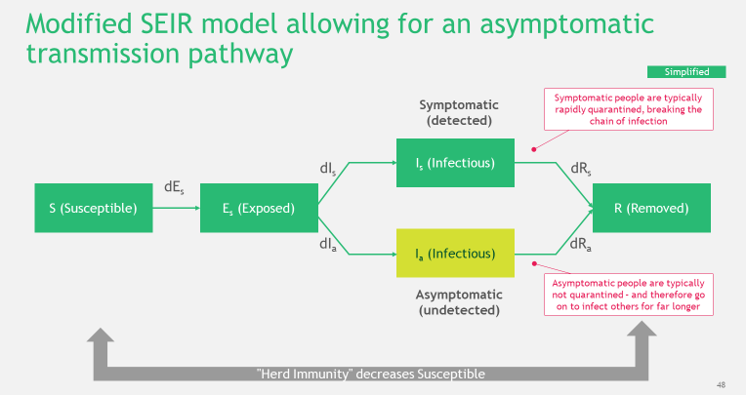

There are a number of key assumptions in our model
- General: Modified SEIR equations are a good approximation to the problem dynamics
- Observed cases: Only symptomatic cases are detected, and no asymptomatic cases are detected
- Transmission rate: Population is homogenously mixed, i.e. any person can infect any other person. No difference in transmission rate between different people (e.g. no age related stratification)
- Effective reproduction rate: Reproduction rate changes over time due to government response to increasing case numbers. Reproduction rate is different for different countries/regions due to population density, viral strain, cultural interaction patterns, etc.
- Viral parameters: Our initial assumption (priors) about the viral incubation period, serial interval, and level of asymptomatic and symptomatic transmission are realistic and well documented (see next slide)

The current model is equivalent to the following equations:

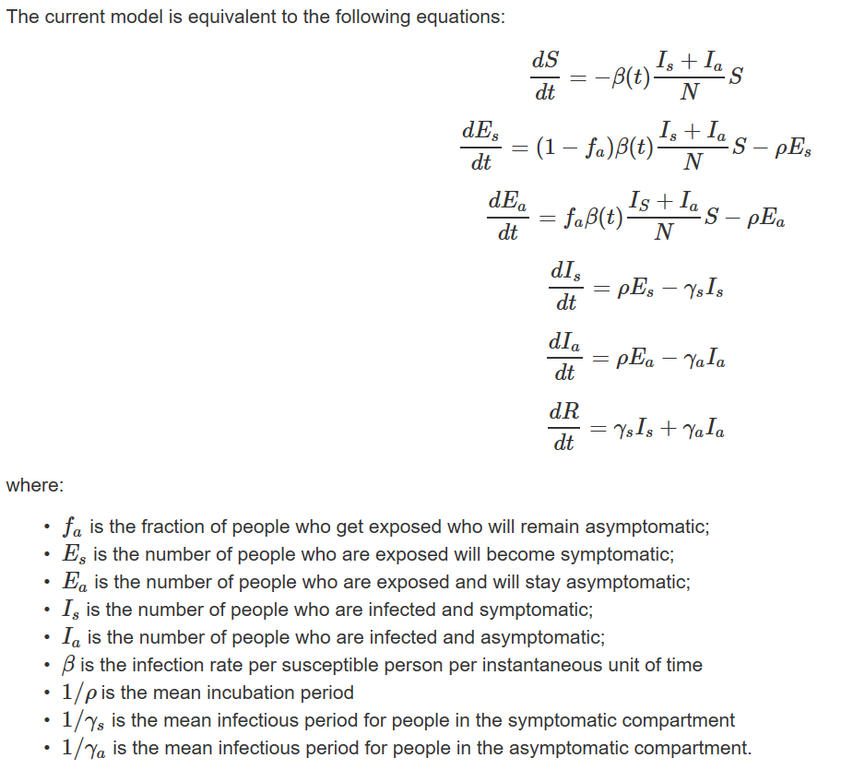

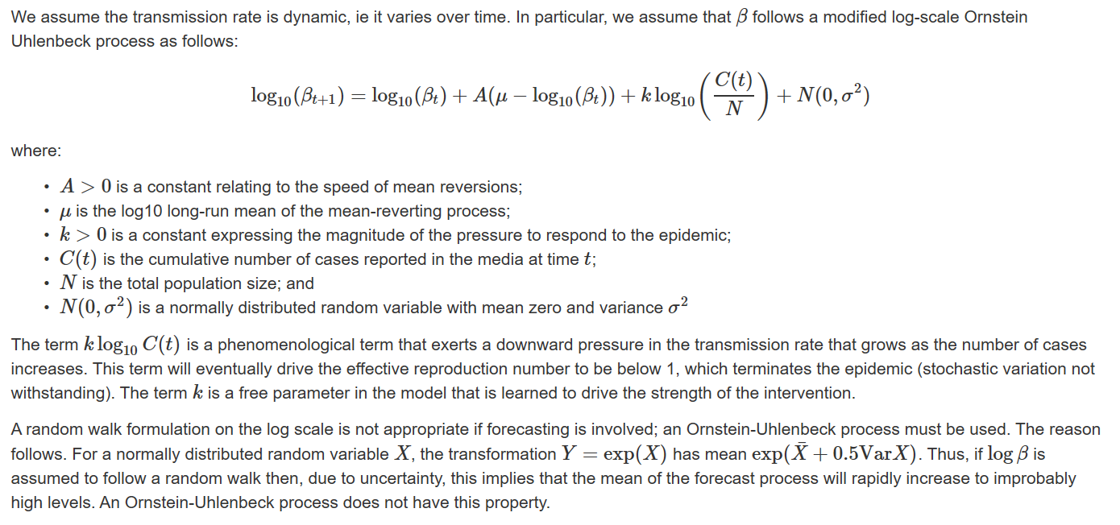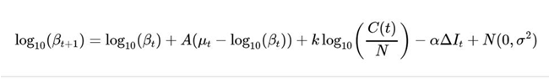

We have used prior information from studies of COVID-19 elsewhere to constrain the range of epidemic parameters
Parameter | Prior mean | Prior distribution | Source
Incubation period | 5.0 days | Log normal with  logmean = 1.621; logsd = 0.1 | Lauer et al. (Annals of IM),  Li et al., (NEJM)
Serial interval for symptomatic | 4.66 days | Log normal with  logmean = 1.539;logsd= 0.19 | Nishiura et al. (IJID)  Tinsdale et al. (Medrxiv)
Serial interval for asymptomatic | 6.74 days | Log normal with  logmean = 1.909; logsd = 0.19 | Tinsdale et al. (Medrxiv)  Imperial college modelling (16 March 2020)
Asymptomatic fraction | 17.8% | Student t with mean of 0.1778 and 4 degrees of freedom | Based on analysis from the Diamond Princess
Presymptomatic transmission period | 0.6 days | Gamma distribution  shape = 6; rate = 10; mode = 0.5 | Imperial college modelling (16 March 2020)
Initial R0 estimate | 2.25 | Log normal logsd = 0.125

We then developed a Stringency Index tailored for the Nigerian context to evaluate the impacts of different NPIs

In our SEIR model, we used the Stringency Index to project the influence of government-imposed non-pharmaceutical interventions (NPIs) on future pandemic spread. Our methodology in building a Stringency Index involved two steps - the calibration of the future influence of all NPIs considered and then the construction of this index using a weighted-sum NPI approach.

First, we calibrated the future influence of each NPI considered to mirror its influence in the past. For example, consider a country that had imposed a lockdown and as a result saw its number of new cases decrease significantly. This effect is captured numerically and is then reused to project future number of cases in that country either if lockdown continues or if it stops.

Second, we performed a weighted-sum of future influences of the NPIs to arrive at a Stringency Index, rescaled to vary between 0 and 100. In doing this, we ensured that the weight assigned to each NPI appropriately reflected its contribution to the Stringency Index. Our approach to defining the weight assigned to each NPI involved fitting a linear regression model on the observed R0 with those of a group of countries similar to Nigeria in terms of GDP per capita and population. From the regression results, we assigned a weight to each NPI that mirrored its past influence in the Stringency Index and thus ensured that these NPIs could be compared against one another.

- Additional detail on SEIR modeling results
The modeling approach described above yielded the following results.

All scenarios assume a theoretical maximum of implementation effectiveness, based on a set of benchmark countries. This level of implementation effectiveness would likely be challenging to achieve, especially social distancing within workplaces. Prior evidence on impact of NPIs is based on levels of effectiveness generally observed within lockdown context, thus impact is likely to be lower if lockdown not in place. This caveat is particularly important for the “combination of NPIs” scenario. The modeled figures are based on best data available at the time of writing, and are not intended to represent definitive projections of the course of the pandemic.

Note that “CoM” stands for Cessation of Movement (colloquially referred to as “lockdown.”)

Median cumulative symptomatic cases by scenario, one month
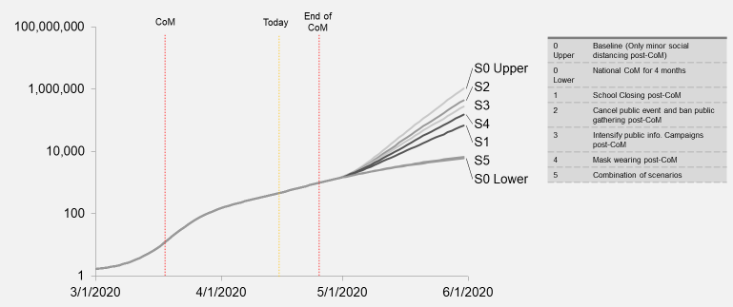

Median new symptomatic cases per day by scenario, one month
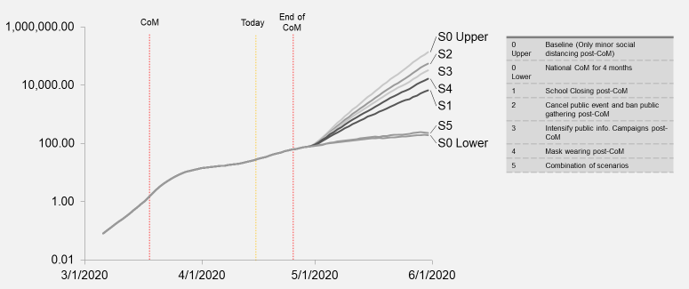

Daily R0 evolution for each scenario (median), one month
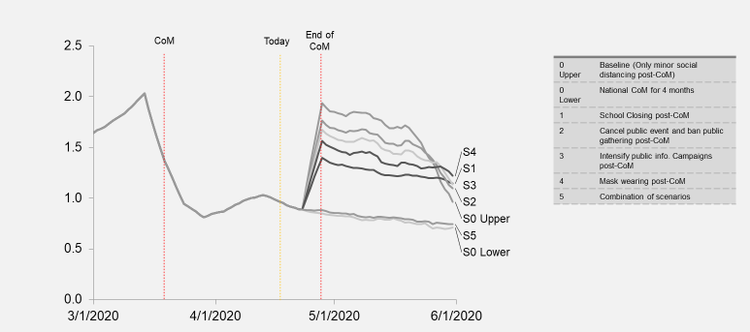

Median cumulative symptomatic cases by scenario, four months
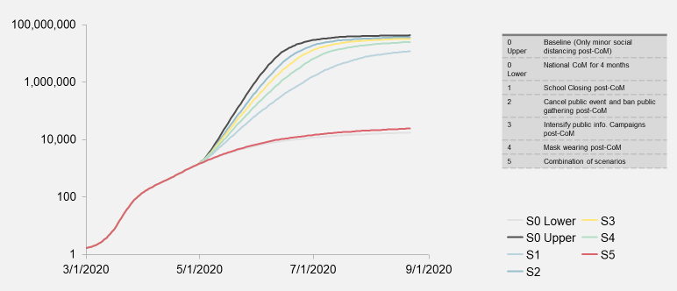

Median new symptomatic cases per day by scenario, four months
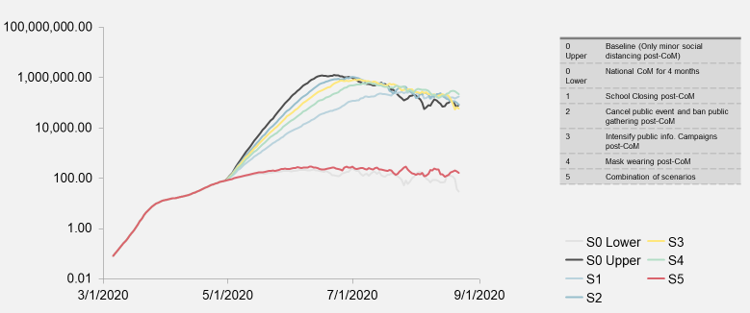

Daily R0 evolution for each scenario (median), four months
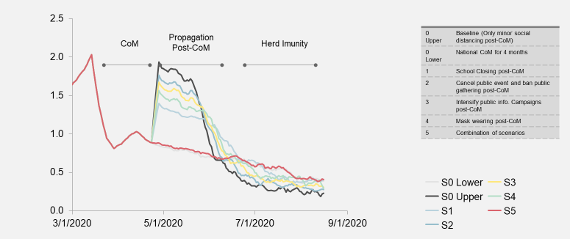

- Wage loss and food security impact methodology

Using high-level economic data and the median symptomatic rate from the SEIR model, we developed directional, static estimates of potential ranges of people impacted by wage loss and food insecurity. These numbers provide a snapshot in time and do not incorporate computational general equilibrium modeling or secondary economic impacts. Moreover, the food security analysis shown does not include any impacts on production, supply chain, global or local food prices. This analysis is intended to be directional only and is in no way a comprehensive picture of economic impact.

For the analysis shared in this paper, the following estimation approach was used:

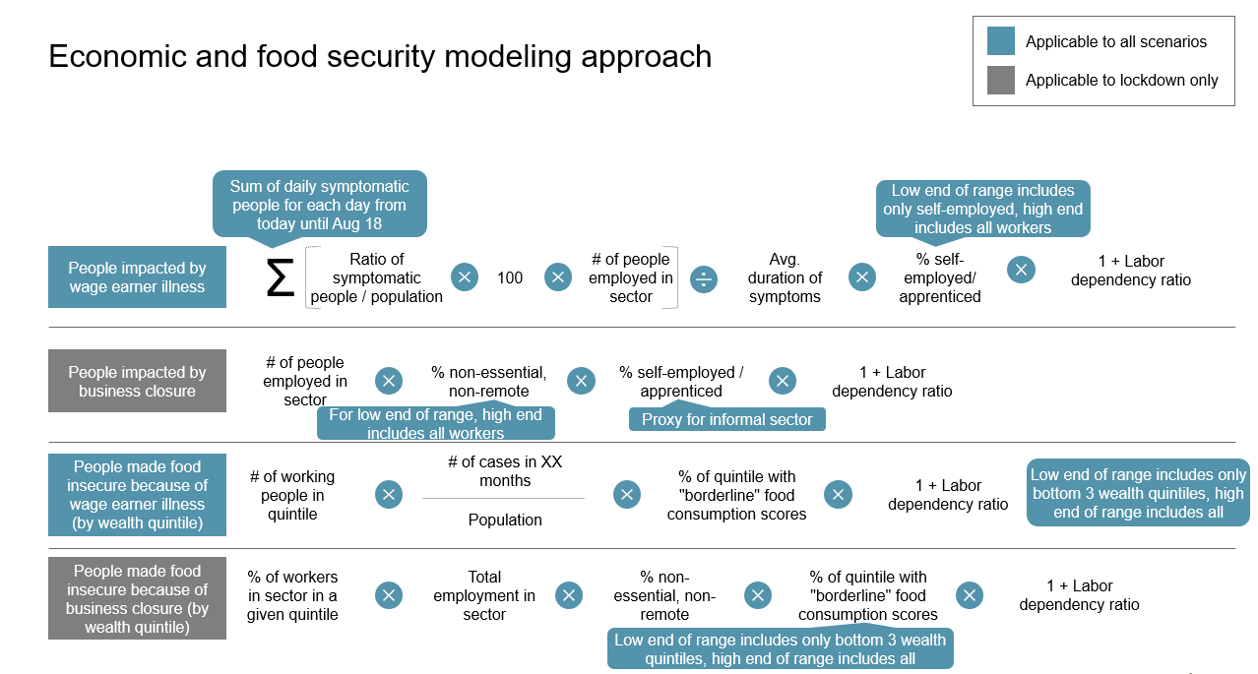
- Operationalization of testing, tracing, and isolation

Evidence from other countries, and implications for Nigeria, on testing, tracing, and isolation:
- Testing: Testing capabilities reported by other countries which subsequently curbed pandemic spread exceed those currently reported by NCDC
  - Estimates from different countries – such as Taiwan and South Korea, which had 27 and 850 new cases per day at peak, respectively - suggest a need for aggressive testing strategies of 60 – 320 daily tests per million people at peak of new cases per day. Even with this level of testing, there is no indication that all asymptomatic cases were identified.
  - With Nigeria’s planned expansion of testing capacity for the next 4-6 weeks (reaching 3,000 tests per day), Nigeria may need an 4x increase in testing capacity while new case onset is at current levels of <100 per day, but this may rise as high as a 20x increase in testing capacity at higher onset levels. While the NCDC strategy does plan for significant expansion of capacity through leveraging high throughput HIV molecular testing laboratories, this expansion could take 6-8 weeks.
  - Required testing estimates for Nigeria could be larger based on the wider geographic distribution of case onsets in Nigeria than in South Korea or Taiwan where cases most prevalent in a few major cities.
  - Alternatively, conducting COVID-19 tests on a representative sample of a population can improve the accuracy of data on the prevalence of COVID-19 infections. For example, a random sample of 5,000 can determine the prevalence of COVID-19 infection of Massachusetts’s population of 7 million within a margin of error of 1.5 percentage points. Given widespread PCR testing may not be fully accessible in Nigeria, this may provide an alternative to improve country projections faster.
  - Note that NCDC’s recently (20th of April) released the national strategy to scale up testing, including a 5-phase approach in line with WHO guidelines on testing for different epidemic stages. Phase (1) Expand the national existing laboratory network with molecular RT-PCR, from 9 laboratories in 6 states currently, to 15 laboratories in 12 states (+ the FCT) and increase testing capacity from 2,500 per day to 3,000 over the next 4-6 weeks. Subsequent phases are (2) Leverage capacity within high throughput HIV molecular testing laboratories – aim of 3,500 additional daily tests in the following 6-8 weeks; (3) Deploy point of care tuberculosis testing capacity – aim of decentralizing testing, strengthening national surveillance, and 1,500 additional daily tests; (4) Support private sector laboratories with molecular testing capacity – aim is to improve redundancy of testing, leveraging a shared cost model, and; (5) Future use of antigen and antibody tests to learn more about the Disease. Phases 1-4 require some repurposing of nationally present machines (e.g. ROCHE Cobas Machines, GeneXperts) previously used in HIV and TB laboratories, but also procurement of new machines and testing kits thereby requiring a reliable and functioning supply chain in order to achieve testing capability targets. It is also not clear to what extent the NCDC is ramping up resources for oncoming phases in tandem with implementation of current ones.
- Tracing: Estimates of necessary tracing capabilities in countries with similar new case counts, exceed those currently reported by WHO Africa
  - Estimates from different countries – such as New Zealand and Iceland which had <100 new cases per day at peak – suggest a need of 40-70 contact tracing staff per million people in order to arrest increase in overall cases.
  - WHO puts Nigeria’s contact tracing staff count at 774 (as of April 4th) employees based on Nigeria’s polio response infrastructure. Based on these benchmarks, Nigeria’s required contact tracing workforce ranges from ~8,000 to 14,000 tracers while new cases remain <100 per day, representing at least a 10X increase from current capacity.
- Isolation: Isolation to prevent spread, particularly in places with high frequency of contact (e.g., households and facilities) requires close monitoring and examination to rule out infection, even if they do not have any symptoms.
  - Nigeria’s home and hospital isolation rules for presumed and confirmed cases respectively are comparable to benchmarks from other countries. However, isolation will have limited impact without large scale lab-testing and tracing as rates of asymptomatic cases will remain unclear and efforts remain untargeted
  - Countries such as Taiwan and South Korea have mandated that non-critical patients as well as at-risk populations (e.g. travel-ins) quarantine at home, and have used app-based trackers to enforce rules, as a strategy to minimize potential asymptomatic spread despite limited case awareness

What does large-scale tracing and isolation look like without widespread testing? India as a case study
Overview
- India is using a mass surveillance and quarantining method to compensate for its limited testing capacity
- This is happening alongside nationwide lockdown
- The method leverages India’s National Surveillance Network (Integrated Disease Surveillance Programme (IDSP)) which already monitors people for communicable disease
How it works
- Where workers identify clusters (unspecified definition) of a disease, a containment zone is set up and everyone inside is ordered to stay at home
- Social workers then go door to door to find people with suspected infections. If a person has symptoms, they are tested for the virus, along with members of their household and close contacts
- People who test positive are taken to isolation units or hospitals
Progress
- So far, more than 4,000 new cases have been identified (out of 6,412 cases as of time of the source – April 10th), with hundreds of thousands of people under surveillance across the nation
Limitations
- Relies on lockdown measures which are not sustainable especially in LMICs with people who rely on daily income or don’t have as much in savings
- Effectiveness requires identifying all cases as missed cases (feasible as some cases are asymptomatic) could easily cause resurgence in infection
- More effective in slum areas where people are more dependent on government services and are more likely to be cooperative. Upper class residents may be incentivized to hide their conditions to avoid social stigma
- Some states more efficient than others in implementation: Kerala is obtaining phone records to investigate the contact histories of people with COVID-19 who are evasive, while in Chennai, a city of roughly seven million people in the state of Tamil Nadu, health workers are going door to door daily to monitor and test anyone showing signs of an influenza-like illness.
Key Requirements and Implications for Nigeria
- Requires a large trained workforce to visit residences in densely populated regions, accurately log symptoms and monitor quarantine compliance, while maintaining worker self-safety
- Requires isolation facilities in (or close to) residential areas once hospitals are fully utilized
- May be difficult to enforce in the most densely populated slums of major cities as people may not be able to quarantine without food and other necessary supplies and may be incentivized to break quarantine
- Nigerian government could consider a similar large-scale tracing and isolation strategy based on mass surveillance and quarantine of residential disease clusters as seen in India. This can provide a feasible and short-term solution to the lack of visibility in disease transmission rates, while allowing the government to continue to develop its testing capabilities. It will require a sizeable workforce, community engagement and may require some levels of police enforcement, but preliminary data from India (identifying the majority of cases) suggest this is an impactful method to combat transmission in lieu of widespread testing.

- Feasibility and operationalization considerations for select NPIs

NPI | Key considerations to operationalize | Case studies from other countries | Implications for Nigeria
School closings  Relative feasibility assessment: High | - When would school closings happen anyway due to vacation?  - When are exams, and can they be delayed?  - What are options for virtual learning?  - How would parents be affected by closures? | - Ghana shut down all schools on the 16th of March and they remain closed indefinitely despite partial lockdown lift  - India offered free online learning platforms and developed 32 TV channels for 24/7 educational programming tailored to school curriculums  - Argentina Ministry of Education has delivered textbooks to low-income families with children outside of school  - Liberia 32 Radio stations broadcast several curriculum based lessons per day  - India (Maharashtra) (Largest state economy in India ) has frozen all school fees during the lock-down to compensate parents and children families until the lockdown | - Examinations Most national exams have been postponed and apart from for a few private schools with online access, there is limited opportunity to conduct online examinations  - Virtual Learning Nigeria could consider offering TV and Radio based educational content as well as delivering textbooks to most in-need pupils, as majority of Nigerian children more likely to be connected to TV and Radio than have computer/laptop/tablet based connectivity needed for platform use. Although steps must be taken to sanitize books if delivery approach is taken  - Family Compensation Nigerian government could consider leveraging education tax fund to financially support in-need families by mandating removal of school fees during school closures
Closing of public gatherings above a certain threshold of people  Relative feasibility assessment: Medium | - What are the major sources of public gatherings, and how likely are Nigerians to comply with social distancing guidelines  - What is ideal limit in gathering size?  - How do we ensure public transport social distancing  - What is needed in terms of police/health worker presence to enforce this  - How do we incentivize compliance from different types of workers (e.g. daily laborers and low-income hourly/daily wage earners) whose wages may rely on public gatherings  - How do we manage rises in social unrest as a result of out-of-work population – especially young people  - What criteria do companies need to could prove they can reopen offices while complying with social distance guidelines | - India police enforce open market distancing partly by drawing lines 2 meters apart, to enforce distancing while customers wait in front of shops,  - South Africa has limited funeral attendance to up to 50 people at a time, and mandated that public transport vehicles only carry 70% of their capacity (if passengers don’t wear approved masks), while adding curfew to operational times  - South Africa issued a COVID-19 guide for employers including requirements for staff PPE and handwashing soap to help employers to minimize COVID-19 spread  - South Africa’s has offered ~1.7B USD from its unemployment insurance fund to parents missing out on wages due to childcare for the 3 month lockdown period  - South Africa issued consumer protection directives to minimize price gouging during COVID-19 with fines of up to R1m or 12 month imprisonment  - South Africa supplemented its 160,000 police force with 2,800 soldiers and has prioritized patrolling high-density residential areas to best utilize limited staff numbers  - Australia has closed all non-essential gatherings (e.g. restaurants, gyms) and limited weddings to 5 people including the couple, funerals to 10 people, while allowing hairdressers/barbers to operate as long as people stay 4 square meters apart. | - Public Gathering Compliance: Large open markets may require enforcement to maintain social distancing, workplaces more likely to comply with guidelines based on the larger collective sense of a health risk involved. Places of worship likely to comply given the support of religious leaders, and leisure centers can easily be mandated to shut-down otherwise. General social gatherings likely to decrease in attendance, but some level of enforcement may be needed  - Public Transport Nigeria could limit public transport capacity to the 70% threshold as seen in South Africa, but will need to consider social distancing at typically crowded bus stops as well  - Essential Public Gatherings Nigeria could adopt similar public gathering limits as Australia who have past their peak (March 28th). More stringent limits likely necessary for Nigeria given the limited capacity for testing, tracing, isolating and enforcing other impactful NPIs in conjunction  - Workplace Best Practice Nigeria could consider a checklist system where non-essential workplaces can confirm adherence to social distance guidelines if they want to resume some in-person business  - Public Unrest Prevention As seen in South Africa, Nigeria could consider leveraging education tax fund similar to South Africa’s use of its unemployment fund to support out-of-work staff due to lockdown, and the government could enforce legislation to prevent price gouging during the lockdown period
Intensification of public information campaigns  Relative feasibility assessment:  High | - How to ensure campaigns reach everyone in timely fashion – including vulnerable (e.g. elderly people, low-income people living in highly-populated shanty towns, people in remote rural villages)  - How to prevent misinformation – Nigerians very reliant on word of mouth (e.g. WhatsApp broadcasts)  - How are people segmented and what is the best format for reaching out to these segments (Radio, TV in certain areas, different languages, community leaders) | - Malawi: Government organized meeting (observing social distancing) of key traditional leaders explaining best ways to disseminate COVID-19 prevention messages to their constituents  - Central African Republic: UN Volunteers have set up bi-weekly radio broadcasts called “Stop Coronavirus” advising rural communities on how to limit spread  - South Africa: Ministerial task team monitors media posts and responds to complaints of misinformation. They offer a complaints logging website and a dedicated WhatsApp number and holding internet service providers responsible for removing misleading information | - Raising Awareness: Nigerian Government could work with popular radio stations as seen in CAR, prioritizing the hardest-to reach rural areas to host daily broadcasts raising awareness of preventative measures and good quarantine practices  - Combating Misinformation: Nigeria could work with Internet Service Providers and popular internet blogs and websites to watch out for misinformation and penalize any users found guilty, as has been done in South Africa
Shelter in-place for vulnerable populations  Relative feasibility assessment:  Low | - How do we support the high-need vulnerable with necessary materials such as food and clean water during isolation  - What proportion of population considered vulnerable and how can they be reached  - What are current living conditions (access to clean water, shanty towns, multi-generational households) and how are they geographically dispersed  - How can Nigeria scale up isolation shelters for these vulnerable populations | - India (Uttar Pradesh): Government to deliver essential food commodities like fruits, milk, vegetables and medicines to support those in quarantine and during lockdown using volunteers and 10,000 supply vehicles  - India: Government is converting 20,000 train carriages into makeshift medical facilities and isolation wards, which each carriage having up to 16 beds to help in-need people with isolation and support healthcare system  - Uganda: Government mandated that travel-ins from its any country on its list of 17 high-risk countries shelter-in at government designated hotels. Travelers are being forced to pay the hotel bills or sleep in the lobbies otherwise | The below applies to all individuals sheltering-in-place including those in quarantine as a result of showing symptoms  - Supporting vulnerable people in isolation: Nigerian government could consider essential material – such as food and medicine – deliveries as seen in Uttar Pradesh (pop. 200m), prioritizing high-need (low income, high population density) regions. This will require strategies to identify high-need regions and coordinate with community leaders to best ensure safety, good distribution and community engagement  - Shelter-in-place Most Nigerians (60%) live in large (4+ people) households and without access to clean water (76%) making it harder to quarantine effectively at home. Nigerian government may could rely on newly developed makeshift isolation centers (churches, mosques, stadiums) to house the vulnerable  - Vulnerable population: Nigeria’s vulnerable population include the elderly (65+ at 2.7%), HIV positive individuals (1%), and patients with diabetes (3.1%) among others, totaling at least 13m people based on a very conservative estimate
Increased diagnosis and case isolation  Relative feasibility assessment:  Low | - What levels of testing and other capabilities (# of tests, skilled staff) is necessary to minimize spread testing  - What tracing and isolation capabilities are needed and what does it take to get there  - What amounts of PPE is needed  - How do we obtain PPE (e.g. local manufacturing, importing) | - Ghana: Eased lockdown after conducting 65,000 tests and tracing 86,000 contacts as of April 20th 2020  - Taiwan: Conducted 60 tests daily per million people at its peak of new cases (20th of March) in order to stem spread  - New Zealand and Iceland: which had <100 new cases per day at peak – employed 40 and 70 contact tracing staff per million respectively in order to arrest increase in cases  - Ghana: Government licensed four Ghanaian manufacturers to produce 3.6 million protective masks among other PPE for in-need health workers and larger population | - Testing Capacity: Nigerian government likely to need between 60 to 320 daily tests per million people based on Taiwan and South Korea benchmarks (both countries past their peaks) in order to limit spread of cases.  - Tracing Capacity: Nigerian government could require at least 8,000 contact tracing staff based on New Zealand benchmarks. The Government could employ the recently unemployed and university students whose degrees have been postponed till the next year as a result of missed exams during the lockdown.  - Isolation: Nigeria’s home and hospital isolation rules for presumed and confirmed cases respectively are comparable to benchmarks from other countries. However, isolation will have limited impact without large scale lab-testing and tracing as rates of asymptomatic cases will remain unclear and efforts remain untargeted  - PPE Production: Nigerian government could partner with large domestic private manufacturers for production of PPE as seen in Ghana
Mask Wearing or face coverings  Relative feasibility assessment:  Medium | - What level of mask wearing is enough, and how to enforce it  - How do we provide accurate information on proper use of and effectiveness/ineffectiveness of masks | - India made mask wearing mandatory for everyone in major cities including Dehli and Mumbai, as well as Uttar Pradesh, the most populous state (pop. 200m), with non-compliance in Mumbai punishable by up to 6 months in prison  - U.S CDC recommends use of cloth based face coverings in public settings to limit spread of COVID-19 and publishes guidelines on size and fitting of appropriate face coverings | - Guidelines on mask wearing: NCDC has already released guidelines on the use of both disposable triple layer masks as well as N95 masks – largely tailored at health professionals. NCDC has also released a more recent guidelines tailored to the COVID-19 outbreak, which is based on WHO guidelines.  - Substitutes to masks: Given shortage of masks and other PPE, Nigerian Government could offer advice on substitutes such as alternative cloth-based face coverings and usage guidelines as seen in the U.S.

- Country case studies
- Case study on Ghana

Several countries have already ended lockdowns or plan to do so in the coming weeks. On April 20th, 2020, Ghana became the first African country to lift its partial lockdown, which had been in place for past three weeks. The partial lockdown was in effect in Accra, Kumasi, Tema and Kasoa, and required that all individuals in those areas remain at home unless for essential reasons such as purchase of food and medicine.

President Akufo Addo announced the end of Ghana’s lockdown, citing its recent ramp up of COVID-19 testing, contact tracing, and isolation capabilities and the severe impact of the lockdown on the poor and vulnerable. Ghana has traced 86,000 contacts so far, tested almost 70,000 of those identified contacts and isolated 930 people in their homes or in a treatment facility largely due to the ramp up in capacity during the partial lockdown. Local factories are producing PPE and Ghana is leveraging drones to transport testing samples to labs.

Still, Ghana has had 1,042 confirmed cases and 9 deaths so far. And despite efforts to improve up virus readiness, Ghana is still awaiting the test results of 18,000 tests.

Moreover, there are only 67 ventilators across Ghana’s public hospitals; although, orders have been placed to eventually reach 200 ventilators. To help keep the number of cases low enough for Ghana’s testing, tracing and isolation capabilities to handle, Ghana has kept other enhanced measures in place:
- Suspension of all public gatherings, including conferences, workshops, funerals, parties, nightclubs, drinking spots, beaches, festivals, political rallies, religious activities and sporting events. Private burials are allowed with 25-person limit.
- All educational facilities, private and public, are to remain closed
- Businesses and other workplaces can continue to operate, observing staff management and workplace protocols with the view to achieving social distancing and hygiene protocols.
- Operators of public transport, including commercial buses, and taxis, are to continue to run with a minimum number of passengers, as they have been doing for the last three weeks, to maintain social distancing. They must also continue to ensure the maintenance of enhanced hygienic conditions in all vehicles and terminals, by providing, hand sanitizers, running water and soap for washing of hands. Domestic airlines are required to adhere to the same protocols.
- The Ministry of Local Government and Rural Development, together with Metropolitan, Municipal and District Assemblies, will continue to implement measures to enhance conditions of hygiene in markets across the country, and expand the policy of alternate-days-for-alternative-products to improve social distancing in all markets.
- Entrepreneurs or those providing public services (i.e. barbers, hairdressers, tailors, taxi drivers, bus driver and assistants, shop keepers, food sellers) are mandated to use masks.
- Extension of the closure of borders for two (2) more weeks, beginning Monday, 20th April.

Ghana’s approach of choosing select NPIs to minimize transmission after ending its lockdown could be replicated in Nigeria. It should be noted Ghana’s strategy was paired with a ramp up of its testing, tracing and isolation capabilities in order to keep the number of cases under control once the economy has reopened. Moreover, the recent nature of Ghana’s ending of its lockdown means the economic and health impact of such a strategy has yet to be verified.
- Case study on India

On March 25th, India implemented a 3 week national lockdown that forbade all but essential activities. The severity of enforcement of the lockdown has prompted concerns for the disproportionate impact on the poor and vulnerable. As a result of the lockdown, there have been incidents of civil unrest – in Surat, hundreds of angry migrant workers blocked roads, vandalized properties, and set fire to tires and vehicles after hearing that the shutdown was to be extended.

On April 13th, the national lockdown was extended until May 3rd with the possibility of relaxing restrictions on April 20th in regions where the virus has been contained. India’s assessment of individual regions’ effectiveness at containing the virus is part of its larger “cluster containment strategy” created for the scenario in which there is a large outbreak amenable to containment. Underlying this strategy is the assumption that given the geographic spread of India, it is unlikely that all of India will be affected similarly even if the number of cases is high in particular areas. As a result, India’s containment strategy is focused on specific geographies, especially considering the large economic impacts associated with a national lockdown. India lays out several NPIs that underpin the containment strategy for a specific cluster:
- Preventative public health measures
- Quarantine and Isolation
- Social distancing measures
- Closure of schools, colleges, and workplaces
- Cancellation of mass gatherings
- Advisory to avoid public places
- Cancellation of public transport
- Enforcement of geographic quarantine

These NPIs are bolstered by surveillance and testing measures, healthcare capacity and psychosocial support in order to control the virus.

Although the “cluster containment strategy” allows India to contain the virus without imposing restrictions on the entire country, the economic impact of such a strategy is still unclear – given the relationship between transmission rates and population density, it is likely that dense urban areas are more likely to be hotspots and thus subject to quarantines. However, dense urban areas also represent a disproportionately large portion of economic productivity – Mumbai, for example, accounts for ~7% of the national GDP and makes up more than a third of overall tax collection in Maharashtra. Moreover, there is limited evidence on the effectiveness of the cluster containment strategy. Further research is required in understanding the economic and health impacts of the “cluster containment strategy.”

The “cluster containment strategy,” however, leverages India’s federal structure, where states can issue state-specific lockdowns and guidelines for more effective containment tailored to the specific regional context. In Maharashtra, for example, the state has implemented the “cluster containment strategy” in its largest cities, as the state has seen a significant rise in the number of cases in Mumbai and its other large cities like Pune and Nagpur. In order to compliment the “cluster containment strategy,” the Chief Minster has also outlined a plan to tackle COVID-19 with 5 pillars: 1) health, 2) migrant labour, 3) economy, 4) agriculture, and 5) day-to-day administration. Specifically under its health pillar, Maharashtra has designated specific COVID-19 and non-COVID hospitals, set up a task force, increased testing, tracing and isolation capabilities while also working to procure more PPE and ventilators. For migrant labour, Maharashtra has set up relief camps that provide three meals a day along with medical assistance. Maharashtra has also set up two task forces on how to gradually lift the lockdown and how to minimize COVID’s large impact on the economy. For agriculture, Maharashtra has taken measure to distribute essentials to tribal communities before the monsoon arrives and has not placed any restrictions on farming activities and commodities. For day-to-day administration, Maharashtra is ensuring that meals are being served for 5 rupees and wheat and rice is provided to orange ration cardholders. The need for a specific COVID-19 strategy in Maharashtra results from the fact that Maharashtra is the state with the highest number of confirmed COVID-19 cases in India.

India’s “cluster containment strategy” provides an alternative NPI strategy to Ghana’s nationally applied select NPIs. Given that Nigeria’s cases are also located in specific regions, such a strategy may be applicable to Nigeria. However, further investigation into effectiveness of geography-specific quarantines and feasibility within the Nigerian context is required, especially since a “cluster containment strategy” relies heavily on surveillance measures and ability to identify hotspots in real time.

Detailed table of country case studies (as of April 15th)
 | When | How | Observed impact
Wuhan | On April 8th, Wuhan lifted its lockdown that had been enacted on January 23rd, after 20 days with no more than 1 new confirmed case per day | Wuhan lifted its travel restrictions and allowed individuals to return to work; however, extensive contract tracing and surveillance measures put in place, schools remained closed, and officials still encouraged individuals to stay home. | No new cases in Hubei region have been reported since Wuhan lifted restrictions on April 8th (as of April 13)
Hokkaido prefecture (Northern Japan) | On March 19th, Hokkaido lifted its state of emergency that had been in place since February 28th, after signs that transmission had slowed and that Hokkaido was “now able to battle (the virus), as we've strengthened the test capability and bed capacity in hospitals.”  On April 12th, Hokkaido announced another state of emergency. | Hokkaido lifted its state of emergency, which urged individuals to refrain from non-essential activities, work from home, and social distance. Following the end of the state of emergency, individuals were allowed to resume normal activities, schools slowly reopened, and some public gatherings were allowed.  On April 12th, Hokkaido’s second state of emergency reversed previous easing and primary and secondary schools were closed until May 6th. | Hokkaido’s governor announced its second state of emergency following a resurgence in number of cases – Hokkaido had seen double digit increases in infections for five days in a row.
Austria | On April 14th, Austria will begin to ease restrictions that had been in place since March 16th, after Austria has seen a steady decline in number of new cases. | Austria has laid out a plan for a gradual reopening, starting with reopening shops under 400 sq m in size along with hardware stores, petrol stations, car washes, and other small non-essential businesses on April 14th. Austria still requires that individuals wear face masks in public.  Larger shops, shopping centres and hairdressers are due to reopen from May 1st while restaurants and hotels could reopen from mid-May if health conditions allow. No public events can be held until at least late-June. | N/A
Spain | On April 13th, Spain began to ease its work restrictions after the number of new cases had been declining. Although Spain still has reported hundreds of new cases a day. Spain’s work restrictions had been in place since a lockdown was implemented on March 14th. | Spain is allowing business that cannot operate remotely to reopen (including construction, manufacturing, etc.).  Although Spain has also reopened its public transit system, Spain has been handing out masks to people using public transportation. Restaurants, shops, and public spaces are set to remain close for another two weeks. | N/A
Italy | On April 14th, Italy began to ease the restrictions which was put in place on March 10th. This is due to the decline in the number of new cases, although the average number of new cases is still about 4,000 daily, it is expected that the restrictions will be completely lifted on May 3rd. | Some regions in Italy reopened some businesses and industries on April 14th. Other regions to follow by April 20.  Businesses that have been allowed to open include bookshops, stationery shops, children’s clothing shops, dry cleaning services, and launderettes. The industries that have been allowed to resume activity include manufacture of computers and other electronics, forestry, landscape maintenance, manufacture of radiators and heaters, wood and cork industries, wholesale of fertilizers and agricultural chemicals.  For shops which have been permitted to reopen, customers are expected to use disposable gloves during shopping and also use masks in closed places/environments and in all workplaces where distance cannot be maintained. In small shops, admittance of people is limited to one at a time and two operators at most to minimise spread and access.  Restrictions on travel and operation of non-essential productive activities are still in place; schools, parks, playgrounds and all sport activities are still suspended.  All other quarantine restrictions remain the same, including the order to stay indoor as much as possible, the ban on public gatherings and the compulsory form needed to justify any trips outside. | N/A
Denmark | On April 15th, Denmark began to ease restrictions which was put in place on March 13th. Although Denmark still records close to 200 cases daily, the ease in restrictions was put in place because the spread of the virus appears to be under control and there is need to resume economic activities. | On April 15th, nurseries, kindergartens, and primary schools reopened since their closure on March 12th. Classes have began in about half of the country’s municipalities and about 35% of schools in Copenhagen. All schools are expected to open by April 20th.  Schools are required to ensure that a distance of two metres is maintained between desks in classrooms, and recesses must be organised for small groups. Pupils should not be in groups of more than two while inside and five while outside.46 Middle and high school students will continue classes remotely and are to return to classrooms on May 10.  On April 14th, Small non-shops were allowed to reopen while maintaining social distance rules and wearing of masks in shops and on public transport.  Bars, restaurants, hairdressing and massage parlours, shopping centres and discos remain closed, and gatherings of more than 10 people are still banned. | N/A
Norway | On April 20th, Norway will begin to ease restrictions which have been in place since March 12th, as the rate of new infections have slowed to a little over 100 cases a day after peaking at 425. | On April 20th, Norway will begin to reopen its kindergartens and on April 27th, Norway is set to reopen the rest of schools and universities.  Norwegians are still advised not to travel abroad and continue working from home but will be allowed to go to their chalets from April 20th.  Services that require personal contact such as hairdressers can be resumed gradually. Ban on large events are to remain in place until June 15th. | N/A
Poland | Beginning April 19th, Poland will slowly reopen its economy, as the daily number of new infections has slowed and held roughly steady in April. Poland’s lockdown has been in place since March 13th. | Restrictions on business will begin to lift on April 19th in Poland. Poles will also have to cover their faces with masks or cloth scarves while in public.  School closures had been extended until April 26th. Limits on air and rail transport have also been extended, with Poland’s borders remaining closed until May 3rd. | N/A
Czech Republic | On April 20th, the Czech Republic will begin easing its restrictions and gradually reopening over the next two months. The Czech government had imposed restrictions on travel, banned large events and closed non-essential businesses after declaring a state of emergency on March 12th. | Beginning April 20th, the Czech Republic will allow craft shops to reopen on April 20th, and a phased return for students to colleges and schools; however high schools are not expected to fully open until September 1st. Essential travel outside of the Czech Republic is now also allowed.  Larger stores will reopen on May 11th, restaurants, snack bars, pubs and wine shops offering items for immediate consumption will reopen from May 25th, and the rest of restaurants and shopping malls on June 8th assuming that the pandemic will be under control. | N/A

The analysis in this paper is purely the work of the Nigeria COVID-19 evidence synthesis group* for use by the PTF. Unauthorized use or publication of this material without the permission of the PTF is prohibited.
* The Nigeria COVID-19 evidence synthesis group is chaired by Prof Ibrahim Abubakar, scientific and technical advisor to the PTF.

References

Jobs per economic activity based on National Bureau of Statistics “National Manpower Stock and Employment Generation Survey,” 2010 and National Bureau of Statistics, “Labour Force Statistics Vol. 2: Employment by Sector” (Q32017).
For more information on food consumption scores, see Kuku-Shittu et al., “Comprehensive Food Security and Vulnerability Analysis: Nigeria,” IFPRI Discussion Paper 01275 July 2013.
High: high likelihood of compliance without stringent enforcement, Medium: strong likelihood of compliance with additional enforcement; Low: low likelihood of compliance even with enforcement
For resources, a high score refers to limited resources required to implement NPI; medium refers to scaling up of resources required but at a reasonable cost or quantity; low refers to a massive scaling up of resources required.
For societal constraints, a high score refers to NPIs with minimal societal disruptions to day to day life; medium refers to some societal disruptions; low refers to major societal disruptions.
Public gatherings may need to be disaggregated, as closing marketplaces and religious events may be less feasible than closing concerts and conferences and should be considered separately.
Stacey Knott, “Ghana's Decision to Lift Partial COVID-19 Lockdown Criticized by Some”, 20/04/20, Accessed 21/04/2020, https://www.voanews.com/africa/ghanas-decision-lift-partial-covid-19-lockdown-criticized-some
Ahram Online, “Egypt cancels third preparatory final year exams, keeps thanaweya amma as scheduled”, Accessed 22/04/2020
World Bank, “How countries are using edtech (including online learning, radio, television, texting) to support access to remote learning during the COVID-19 pandemic” Accessed 20/04/2020 https://www.worldbank.org/en/topic/edutech/brief/how-countries-are-using-edtech-to-support-remote-learning-during-the-covid-19-pandemic
World Bank, “How countries are using edtech (including online learning, radio, television, texting) to support access to remote learning during the COVID-19 pandemic” Accessed 20/04/2020 https://www.worldbank.org/en/topic/edutech/brief/how-countries-are-using-edtech-to-support-remote-learning-during-the-covid-19-pandemic
Lucinda Rouse, “Liberia takes classes to the airwaves during COVID-19 pandemic” Aljazeera News, 16/04/2020, Accessed 21/04/2020 https://www.aljazeera.com/news/2020/04/liberia-takes-classes-airwaves-covid-19-pandemic-200415203012448.html
India Today Web Desk, “Covid-19 Lockdown: Maharashtra education minister asks schools not to collect fees till May 3”, 17/04/2020, Accessed 20/04/2020 https://www.indiatoday.in/education-today/news/story/covid-19-lockdown-maharashtra-education-minister-asks-schools-not-to-collect-fees-till-may-3-1668074-2020-04-17
SA News, “Transport revises taxi regulations during lockdown”, 01/04/2020, Accessed 21/04/2020, https://www.sanews.gov.za/south-africa/transport-revises-taxi-regulations-during-lockdown
Devika Desai, “COVID-19 India: This is how local police punish anyone who violates nation's 21-day lockdown”, National Post, 26/03/2020, https://nationalpost.com/news/world/covid-19-india-this-is-how-local-police-punish-anyone-who-violates-nations-21-day-lockdown
Hotismolimo Mutlowka, “Fighting COVID 19: Supportive Measures for Businesses and Workers in South Africa”, Verfassungsblog on matters constitutional, 30/03/2020, Accessed 20/04/2020, https://verfassungsblog.de/fighting-covid-19-supportive-measures-for-businesses-and-workers-in-south-africa/
UNICEF, “Sensitizing community leaders to prevent and prepare for the COVID-19 in Malawi”, 27/03/2020, Accessed 21/04/2020 https://www.unicef.org/malawi/stories/sensitizing-community-leaders-prevent-and-prepare-covid-19-malawi
UN Volunteers, “Fighting COVID-19 through public information in the Central African Republic”, 13/04/2020, Accessed 21/04/2020 https://www.unv.org/Our-stories/Fighting-COVID-19-through-public-information-Central-African-Republic
CNBC Africa, “Coronavirus – South Africa: Government monitors and responds to misinformation and fake news during Coronavirus Covid-19 lockdown”, 15/04/2020, Accessed 21/04/20 https://www.cnbcafrica.com/africa-press-office/2020/04/15/coronavirus-south-africa-government-monitors-and-responds-to-misinformation-and-fake-news-during-coronavirus-covid-19-lockdown/
Neha Lalchandani, “In UP cities, Yogi Adityanath government to deliver food at doorsteps”, 25/03/2020, Accessed 21/04/2020, https://timesofindia.indiatimes.com/city/lucknow/in-up-cities-yogi-govt-to-deliver-food-at-doorsteps/articleshow/74801371.cms
Aljazeera, “India turns trains into isolation wards as COVID-19 cases rise”, 02/04/2020, Accessed 21/04/2020 https://www.aljazeera.com/news/2020/04/india-turns-trains-isolation-wards-covid-19-cases-rise-200402071515155.html
World Bank Data, “Population ages 65 and above (% of total population)”, Accessed 21/04/2020, https://data.worldbank.org/indicator/SP.POP.65UP.TO.ZS
UNAIDS, “Nigeria Overview”, Accessed 21/04/2020, https://www.unaids.org/en/regionscountries/countries/nigeria
Oguoma, V.M., Nwose, E.U., Ulasi, I.I. et al. Cardiovascular disease risk factors in a Nigerian population with impaired fasting blood glucose level and diabetes mellitus. BMC Public Health 17, 36 (2017). https://doi.org/10.1186/s12889-016-3910-3
UN, “Household Size and Composition Around the World 2017”, Accessed 21/04/2020, https://www.google.com/search?q=average+people+per+household+nigeria&rlz=1C1CHBD_enNG859NG859&oq=average+people+per+household+nigeria&aqs=chrome..69i57.5767j0j7&sourceid=chrome&ie=UTF-8
WHO, UNICEF, "Estimates on the use of water, sanitation and hygiene by country (2000-2017)", Accessed 21/04/2020, https://data.unicef.org/topic/water-and-sanitation/drinking-water/
The Independent, “Coronavirus: India makes face masks mandatory for more than 300m people, punishable by up to six months in prison”09/04/2020, Accessed 21/04/2020 https://www.independent.co.uk/news/world/asia/coronavirus-india-face-masks-prison-police-who-delhi-mumbai-a9458516.html
CDC, “Use of Cloth Face Coverings to Help Slow the Spread of COVID-19”, Center for Disease Control and Prevention, Accessed 21/04/20 https://www.cdc.gov/coronavirus/2019-ncov/prevent-getting-sick/diy-cloth-face-coverings.html
Vanguard News, “COVID-19: We’ll increase test capacity to 1500 per day – NCDC” Vanguard, March 31, 2020
Johns Hopkins University, Center for Systems Science and Engineering, “Coronavirus COVID-19 Global cases,” Accessed April 16th 2020.
Citi Newsroom, “COVID-19: Local production of PPE begins in Ghana [Photos]”, 12/04/2020, Accessed 21/04/2020, https://citinewsroom.com/2020/04/covid-19-local-production-of-ppe-begins-in-ghana-photos/
Lauer SA, Grantz KH, Bi Q, et al. The Incubation Period of Coronavirus Disease 2019 (COVID-19) From Publicly Reported Confirmed Cases: Estimation and Application. Ann Intern Med. 2020; [Epub ahead of print 10 March 2020]. doi: https://doi.org/10.7326/M20-0504
Li et al., “Early Transmission Dynamics in Wuhan, China, of Novel Coronavirus-Infected Pneumonia,” New England Journal of Medisin, March 26, 2020; 382:1199-1207.
Nisihura, et al., “Serial interval of novel coronavirus (COVID-19) infections,” International Journal of Infectious Diseases March 4, 2020, 93:284-286.
Tindale, et al. “Transmission interval estimates suggest pre-symptomatic spread of COVID-19,” MedRxiv pre-print, March 6, 2020.
Ibid.
Ferguson, et al. “Report 9: Impact of non-pharmaceutical interventions (NPIs) to reduce COVID-19 mortality and healthcare demand,” Imperial College COVID-19 Response Team March 16, 2020.
Mizumoto, et al., "Estimating the asymptomatic proportion of coronavirus disease 2019 (COVID-19) cases on board the Diamond Princess cruise ship, Yokohama, Japan, 2020," Eurosurveillance March 12, 2020, 25:10.
Ferguson, et al. “Report 9: Impact of non-pharmaceutical interventions (NPIs) to reduce COVID-19 mortality and healthcare demand,” Imperial College COVID-19 Response Team March 16, 2020.
Petherick, et al., “Variation in Government Responses to COVID-19,” Oxford Blavatnik School Working Paper April 7, 2020
Vanguard News, “COVID-19: We’ll increase test capacity to 1500 per day – NCDC” Vanguard, March 31, 2020
Niall McCarthy, “Has South Korea Stabilized Its COVID-19 Outbreak? [Infographic]” Forbes, March 11, 2020; Nigeria CDC “National Strategy to Scale up Access to Coronavirus Disease Testing in Nigeria,” published April 15th 2020.
Nigeria CDC “National Strategy to Scale up Access to Coronavirus Disease Testing in Nigeria,” published April 15th 2020.
Johns Hopkins University, Center for Systems Science and Engineering, “Coronavirus COVID-19 Global cases,” Accessed April 16th 2020.
David E. Bloom and David Canning, “How to get better COVID-19 infection data without universal testing”, Boston Globe, 15 April 2020
NCDC, “National Strategy to Scale Up Access to Coronavirus Disease Testing in Nigeria”, Accessed 21/04/2020
Johns Hopkins University, Center for Systems Science and Engineering, “Coronavirus COVID-19 Global cases,” Accessed April 16th 2020.
Crystal Watson, Anita Cicero, James Blumenstock, Michael Fraser, “A National Plan to Enable Comprehensive COVID-19 Case Finding and Contact Tracing in the US” John Hopkins, Bloomberg Public School of Health, Astho, Accessed April 16, 2020.
WHO, “Nigeria’s polio infrastructure bolster COVID-19 response”, WHO, Accessed April 16, 2020
Eun-Young Jeong, “South Korea Tracks Virus Patients’ Travels—and Publishes Them Online” Wall Street Journal, February 16 2020
Gayathri Vaidyanathan, “People power: How India is attempting to slow the coronavirus”, 10/04/2020, Accessed 22/04/2020 https://www.nature.com/articles/d41586-020-01058-5
Stacey Knott, “Ghana's Decision to Lift Partial COVID-19 Lockdown Criticized by Some”, 20/04/20, Accessed 21/04/2020, https://www.voanews.com/africa/ghanas-decision-lift-partial-covid-19-lockdown-criticized-some
World Bank, “How countries are using edtech (including online learning, radio, television, texting) to support access to remote learning during the COVID-19 pandemic” Accessed 20/04/2020 https://www.worldbank.org/en/topic/edutech/brief/how-countries-are-using-edtech-to-support-remote-learning-during-the-covid-19-pandemic
World Bank, “How countries are using edtech (including online learning, radio, television, texting) to support access to remote learning during the COVID-19 pandemic” Accessed 20/04/2020 https://www.worldbank.org/en/topic/edutech/brief/how-countries-are-using-edtech-to-support-remote-learning-during-the-covid-19-pandemic
Lucinda Rouse, “Liberia takes classes to the airwaves during COVID-19 pandemic” Aljazeera News, 16/04/2020, Accessed 21/04/2020 https://www.aljazeera.com/news/2020/04/liberia-takes-classes-airwaves-covid-19-pandemic-200415203012448.html
India Today Web Desk, “Covid-19 Lockdown: Maharashtra education minister asks schools not to collect fees till May 3”, 17/04/2020, Accessed 20/04/2020 https://www.indiatoday.in/education-today/news/story/covid-19-lockdown-maharashtra-education-minister-asks-schools-not-to-collect-fees-till-may-3-1668074-2020-04-17
Devika Desai, “COVID-19 India: This is how local police punish anyone who violates nation's 21-day lockdown”, National Post, 26/03/2020, https://nationalpost.com/news/world/covid-19-india-this-is-how-local-police-punish-anyone-who-violates-nations-21-day-lockdown
SA News, “Transport revises taxi regulations during lockdown”, 01/04/2020, Accessed 21/04/2020, https://www.sanews.gov.za/south-africa/transport-revises-taxi-regulations-during-lockdown
Hotismolimo Mutlowka, “Fighting COVID 19: Supportive Measures for Businesses and Workers in South Africa”, Verfassungsblog on matters constitutional, 30/03/2020, Accessed 20/04/2020, https://verfassungsblog.de/fighting-covid-19-supportive-measures-for-businesses-and-workers-in-south-africa/
MSN News, “Preparation is key to policing a crisis like Covid-19”, 20/04/2020, Accessed 21/04/2020 https://www.msn.com/en-za/news/national/preparation-is-key-to-policing-a-crisis-like-covid-19/ar-BB12UJI7#image=1
Australian Government Department of Health, “Limits on public gatherings for coronavirus (COVID-19)”, Accessed 21/04/2020, https://www.health.gov.au/news/health-alerts/novel-coronavirus-2019-ncov-health-alert/how-to-protect-yourself-and-others-from-coronavirus-covid-19/limits-on-public-gatherings-for-coronavirus-covid-19
Tableau Coronavirus Daily Global Tracker, Accessed 21/04/2020, https://www.tableau.com/covid-19-coronavirus-data-resources?utm_campaign=2017049_EGCore_CORPR_USCA_en-US_2020-04-16-Cust-COVID-Company-Statement&utm_medium=Email&utm_source=Eloqua&domain=bcg.com&eid=CTBLS000020269509&elqTrackId=ed020165975c47018580663eeb6cc8a6&elq=f63c4a90595040ce94b551173b99960e&elqaid=42709&elqat=1&elqCampaignId=41953
UNICEF, “Sensitizing community leaders to prevent and prepare for the COVID-19 in Malawi”, 27/03/2020, Accessed 21/04/2020 https://www.unicef.org/malawi/stories/sensitizing-community-leaders-prevent-and-prepare-covid-19-malawi
UN Volunteers, “Fighting COVID-19 through public information in the Central African Republic”, 13/04/2020, Accessed 21/04/2020 https://www.unv.org/Our-stories/Fighting-COVID-19-through-public-information-Central-African-Republic
CNBC Africa, “Coronavirus – South Africa: Government monitors and responds to misinformation and fake news during Coronavirus Covid-19 lockdown”, 15/04/2020, Accessed 21/04/20 https://www.cnbcafrica.com/africa-press-office/2020/04/15/coronavirus-south-africa-government-monitors-and-responds-to-misinformation-and-fake-news-during-coronavirus-covid-19-lockdown/
Neha Lalchandani, “In UP cities, Yogi Adityanath government to deliver food at doorsteps”, 25/03/2020, Accessed 21/04/2020, https://timesofindia.indiatimes.com/city/lucknow/in-up-cities-yogi-govt-to-deliver-food-at-doorsteps/articleshow/74801371.cms
Aljazeera, “India turns trains into isolation wards as COVID-19 cases rise”, 02/04/2020, Accessed 21/04/2020 https://www.aljazeera.com/news/2020/04/india-turns-trains-isolation-wards-covid-19-cases-rise-200402071515155.html
Oryem Nyeko, “Ugandans Trying to Get Home Forced to Pay for COVID-19 Quarantine”, Human Rights Watch, 19/03/2020, Accessed 21/04/2020, https://www.hrw.org/news/2020/03/19/ugandans-trying-get-home-forced-pay-covid-19-quarantine
UN, “Household Size and Composition Around the World 2017”, Accessed 21/04/2020, https://www.google.com/search?q=average+people+per+household+nigeria&rlz=1C1CHBD_enNG859NG859&oq=average+people+per+household+nigeria&aqs=chrome..69i57.5767j0j7&sourceid=chrome&ie=UTF-8
WHO, UNICEF, "Estimates on the use of water, sanitation and hygiene by country (2000-2017)", Accessed 21/04/2020, https://data.unicef.org/topic/water-and-sanitation/drinking-water/
World Bank Data, “Population ages 65 and above (% of total population)”, Accessed 21/04/2020, https://data.worldbank.org/indicator/SP.POP.65UP.TO.ZS
UNAIDS, “Nigeria Overview”, Accessed 21/04/2020, https://www.unaids.org/en/regionscountries/countries/nigeria
Oguoma, V.M., Nwose, E.U., Ulasi, I.I. et al. Cardiovascular disease risk factors in a Nigerian population with impaired fasting blood glucose level and diabetes mellitus. BMC Public Health 17, 36 (2017). https://doi.org/10.1186/s12889-016-3910-3
Vanguard News, “COVID-19: We’ll increase test capacity to 1500 per day – NCDC” Vanguard, March 31, 2020
Johns Hopkins University, Center for Systems Science and Engineering, “Coronavirus COVID-19 Global cases,” Accessed April 16th 2020.
Crystal Watson, Anita Cicero, James Blumenstock, Michael Fraser, “A National Plan to Enable Comprehensive COVID-19 Case Finding and Contact Tracing in the US” John Hopkins, Bloomberg Public School of Health, Astho, Accessed April 16, 2020.
Citi Newsroom, “COVID-19: Local production of PPE begins in Ghana [Photos]”, 12/04/2020, Accessed 21/04/2020, https://citinewsroom.com/2020/04/covid-19-local-production-of-ppe-begins-in-ghana-photos/
The Independent, “Coronavirus: India makes face masks mandatory for more than 300m people, punishable by up to six months in prison”09/04/2020, Accessed 21/04/2020 https://www.independent.co.uk/news/world/asia/coronavirus-india-face-masks-prison-police-who-delhi-mumbai-a9458516.html
CDC, “Use of Cloth Face Coverings to Help Slow the Spread of COVID-19”, Center for Disease Control and Prevention, Accessed 21/04/20 https://www.cdc.gov/coronavirus/2019-ncov/prevent-getting-sick/diy-cloth-face-coverings.html
The Presidency, “President Akufo-Addo Lifts Partial Lockdown, But Keeps Other Enhanced Measures In Place,” The Republic of Ghana, April 20, 2020, http://www.presidency.gov.gh/index.php/briefing-room/news-style-2/1565-president-akufo-addo-lifts-partial-lockdown-but-keeps-other-enhanced-measures-in-place; Thomas Naadi, “Ghana lifts lockdown after ‘enhanced testing”, BBC News, Accra, April 20, 2020; Kwasi Gyamfi Asiedu, “Ghana has become the first African country to lift its coronavirus lockdown,” Quartz Africa, April 20, 2020.
Moses Dontoh, “Ghana Orders Lockdown in Biggest Cities to Combat Virus” Bloomberg News, March 27, 2020.
The Presidency, “President Akufo-Addo Lifts Partial Lockdown, But Keeps Other Enhanced Measures In Place,” The Republic of Ghana, April 20, 2020, http://www.presidency.gov.gh/index.php/briefing-room/news-style-2/1565-president-akufo-addo-lifts-partial-lockdown-but-keeps-other-enhanced-measures-in-place.
Thomas Naadi, “Ghana lifts lockdown after ‘enhanced testing”, BBC News, Accra, April 20, 2020; The Presidency, “President Akufo-Addo Lifts Partial Lockdown, But Keeps Other Enhanced Measures In Place,” The Republic of Ghana, April 20, 2020, http://www.presidency.gov.gh/index.php/briefing-room/news-style-2/1565-president-akufo-addo-lifts-partial-lockdown-but-keeps-other-enhanced-measures-in-place; Abdur Rahman Alfa Shaban, “April 19: Ghana lifts partial lockdown”, April 20, 2020.
Bukola Adebayo, “Ghana lifts lockdown, citing improved testing and ‘severe’ impact on the poor,” CNN, April 20, 2020; Ekow Dontoh and Moses Mozart Dzawu, “Ghana President Lifts Lockdown on Improved Virus Readiness,” Bloomberg News, April 19, 2020.
Bukola Adebayo, “Ghana lifts lockdown, citing improved testing and ‘severe’ impact on the poor,” CNN, April 20, 2020
Ekow Dontoh and Moses Mozart Dzawu, “Ghana President Lifts Lockdown on Improved Virus Readiness,” Bloomberg News, April 19, 2020.
Ekow Dontoh and Moses Mozart Dzawu, “Ghana President Lifts Lockdown on Improved Virus Readiness,” Bloomberg News, April 19, 2020.
The Presidency, “President Akufo-Addo Lifts Partial Lockdown, But Keeps Other Enhanced Measures In Place,” The Republic of Ghana, April 20, 2020, http://www.presidency.gov.gh/index.php/briefing-room/news-style-2/1565-president-akufo-addo-lifts-partial-lockdown-but-keeps-other-enhanced-measures-in-place
Aljazeera, “India reports biggest one-day coronavirus spike as lockdown eased,” April 20, 2020.
BBC News, “Coronavirus: India to extend nationwide lockdown, state minister says,” April 11, 2020.
BBC News, “Coronavirus: India to extend nationwide lockdown, state minister says,” April 11, 2020.
Aljazeera, “India extends world’s biggest coronavirus lockdown till May 3,” April 13, 2020.
Ministry of Health and Family Welfare, “Containment Plan for Large Outbreaks Novel Coronavirus Disease 2019 (COVID-19),” Government of India, April 2020, https://www.mohfw.gov.in/pdf/3ContainmentPlanforLargeOutbreaksofCOVID19Final.pdf.
Greg Clark and Tim Moonen, “Mumbai: India’s Global City,” Global Cities Initiative (Brookings and JPMorgan Chase), December 2014; BBC News, “Coronavirus: India to extend nationwide lockdown, state minister says,” April 11, 2020.
Surendra P Gangan, “In Maharashtra’s Covid-19 containment plan, Mumbai, Nagpur and Pune are key,” Hindustan Times, April 6, 2020.
Sanchita Nambiar, “Maharashtra announces five-point plan to fight COVID-19,” Business Traveller, April 16, 2020.
Sanchita Nambiar, “Maharashtra announces five-point plan to fight COVID-19,” Business Traveller, April 16, 2020.
Sanchita Nambiar, “Maharashtra announces five-point plan to fight COVID-19,” Business Traveller, April 16, 2020
Sanchita Nambiar, “Maharashtra announces five-point plan to fight COVID-19,” Business Traveller, April 16, 2020
Sanchita Nambiar, “Maharashtra announces five-point plan to fight COVID-19,” Business Traveller, April 16, 2020
Sanchita Nambiar, “Maharashtra announces five-point plan to fight COVID-19,” Business Traveller, April 16, 2020
Economic Times, “Coronavirus cases in India: state-wise break up of confirmed coronavirus cases,” April 21, 2020.
Johns Hopkins University, Center for Systems Science and Engineering, “Coronavirus COVID-19 Global cases,” April 13th 2020.
Johns Hopkins University, Center for Systems Science and Engineering, “Coronavirus COVID-19 Global cases,” April 13th 2020.
Kyodo, “Hokkaido set to lift coronavirus state of emergency,” Japan Times, March 19, 2020.
Kyodo, “Hokkaido declares new state of emergency amid ‘second wave’ of coronavirus infections,” Japan Times, April 13, 2020.
Scott Neuman, "Emergency Declared in Japanese Prefecture Hit by 2nd Wave of Coronavirus Infections," NPR, April 13, 2020.
Kyodo, “Hokkaido declares new state of emergency amid ‘second wave’ of coronavirus infections,” Japan Times, April 13, 2020.
"Coronavirus: Austria and Italy reopen some shops as lockdown eased," BBC, April 14, 2020.
Johns Hopkins University, Center for Systems Science and Engineering, “Coronavirus COVID-19 Global cases,” April 13th 2020.
Johns Hopkins University, Center for Systems Science and Engineering, “Coronavirus COVID-19 Global cases,” April 13th 2020.; Alex Matthews, “Austria relaxes coronavirus lockdown measures,” DW, April 13, 2020.
Scott Neuman, “Hard-Hit Spain Tries a Gradual Easing of its Coronavirus Lockdown,” NPR, April 13, 2020.
Lili Bayer and Stephen Brown, “Europe Begins Tentative Easing of Coronavirus Lockdown,” Politico, April 14, 2020.
Allison McCann, Nadja Popovich and Jin Wu, “Italy’s virus shutdown came too late. What happens now?”, New York Times, April 5, 2020
Italy Ministry of Health, “Conte: restrictive measures extended to 3 May”, Italy Ministry of Health, April 11, 2020; Allison McCann, Nadja Popovich and Jin Wu, “Italy’s virus shutdown came too late. What happens now?”, New York Times, April 5, 2020
Michelle Bertelli, “Italy to remain in lockdown until at least May 3”, Aljazeera, April 10, 2020
Italy Ministry of Health, “Which shops reopen, in which regions; more stringent hygiene measures for shopping”, Italy Ministry of Health, April 14, 2020
The Local Denmark, “Here are the businesses that can start reopening in Italy”, The Local Denmark, April 15, 2020
Italy Ministry of Health, “Which shops reopen, in which regions; more stringent hygiene measures for shopping”, Italy Ministry of Health, April 14, 2020
Italy Ministry of Health, “Which shops reopen, in which regions; more stringent hygiene measures for shopping”, Italy Ministry of Health, April 14, 2020
Italy Ministry of Health, “Which shops reopen, in which regions; more stringent hygiene measures for shopping”, Italy Ministry of Health, April 14, 2020
The Local Denmark, “Denmark first in Europe to reopen schools after coronavirus lockdown”, The Local Denmark, April 15, 2020
The Local Denmark, “Here are the businesses that can start reopening in Italy”, The Local Denmark, April 15, 2020
The Local Denmark, “Denmark first in Europe to reopen schools after coronavirus lockdown”, The Local Denmark, April 15, 2020.
The Local Denmark, “Denmark first in Europe to reopen schools after coronavirus lockdown”, The Local Denmark, April 15, 2020.
The Local Denmark, “Denmark first in Europe to reopen schools after coronavirus lockdown”, The Local Denmark, April 15, 2020.
Stephen Treloar, “Norway Starts Easing Restrictions With Virus Seen as Under Control,” Bloomberg, April 7, 2020; “Norway extends coronavirus lockdown until after Easter,” The Local, March 24, 2020.
Laura Smith-Spark, “These countries are reopening after coronavirus- here’s how they’re doing it,” CNN, April 15, 2020.
Gwladys Fouche and Victoria Klesty, “Norway to ease curbs ‘little by little’ after coronavirus lockdown: PM,” Reuters, April 7, 2020
Stephen Treloar, “Norway Starts Easing Restrictions With Virus Seen as Under Control,” Bloomberg, April 7, 2020
Agnieszka Barteckzko and Pawel Florkiewicz, “Poland to Begin Easing Coronavirus Curbs From Sunday with Eye on May Vote,” US News, April 14, 2020.
Marcin Bielecki, Aleksander Kozminski, Piotr Nowak, “Poland in COVID-19 LOCKDOWN! PM orders bars, restaurants, shopping centres and borders closed – and cancels ALL flights,” The First News, April 16, 2020.
Agnieszka Barteckzko and Pawel Florkiewicz, “Poland to Begin Easing Coronavirus Curbs From Sunday with Eye on May Vote,” US News, April 14, 2020.
Agnieszka Barteckzko and Pawel Florkiewicz, “Poland to Begin Easing Coronavirus Curbs From Sunday with Eye on May Vote,” US News, April 14, 2020.
Robert Muller, “Czechs to lift coronavirus lockdown on shops, restaurants over next two months,” Reuters, April 14, 2020.
Laura Smith-Spark, “These countries are reopening after coronavirus- here’s how they’re doing it,” CNN, April 15, 2020.
Laura Smith-Spark, “These countries are reopening after coronavirus- here’s how they’re doing it,” CNN, April 15, 2020.
Robert Muller, “Czechs to lift coronavirus lockdown on shops, restaurants over next two months,” Reuters, April 14, 2020; Laura Smith-Spark, “These countries are reopening after coronavirus- here’s how they’re doing it,” CNN, April 15, 2020.

