Position Paper 5: Initial Findings on Pandemic Trajectory at Sub-national Level

May 5, 2020

Purpose of memo: To share initial findings on pandemic trajectory at sub-national level, compare with COVID-19 burden estimates from other models and impact of COVID-19 on other diseases of public health significance.

Methodology: We use a modified, stochastic, Bayesian SEIR model that accounts for asymptomatic and symptomatic cases among infectious populations (as described in previous position papers). This model incorporates case data from the NCDC as of May 4, 2020. The model builds upon estimates shared in the April 22 position paper with two critical updates. First, it incorporates most recently available data, which shows an increased rate of growth in confirmed cases, driven by factors including the increased testing rate (Appendix 1) and the growth of cases in Northern Nigeria (e.g. Kano). Second, the model’s methodology has been updated to reflect differential expected effectiveness for each NPI in the Nigerian context, whereas the previous model applied the same measure of expected effectiveness to all NPIs. Estimates using this methodology for the number of confirmed symptomatic cases fall at the 80th percentile of the 1-month estimates shared on April 22. Retroactively applying this version of the model to data up through April 22 yields a median estimate of 2,080 (80% CI: 1,166-8,146) cases as of May 3, compared to an actual number of 2,558. Regarding the categorization of the states, we use the NCDC grouping by total number of confirmed cases as of May 3. Pandemic trajectory for states with 100 cases or more (Lagos, FCT, and Kano) are modeled individually. States with fewer than 100 cases are modeled as a group under “Other states” (Appendix 2). For comparison, we present national estimates from other published COVID-19 models and summarized data from multiple models on non-COVID impact.

Findings from the SEIR model: Findings from our SEIR model are shared below for two different scenarios following the lockdown order ending May 4 in Lagos and FCT and ending May 18 in all other states. In Scenario 1, national application of the full set of NPIs announced by the government on April 27 (ban on public gatherings, inter-state travel, continued closure of schools, and mask wearing). In Scenario 2, only limited social distancing and no other NPIs applied nationally.

Scenario 1. Expected pandemic trajectory with CoM ending May 4 in Lagos / FCT and May 18 in other states, replaced with NPIs announced on April 27.

 | By May 18, 2020 (2 weeks) |  |  |  |  | By Sept. 4, 2020
 | Lagos | FCT | Kano | Other states | Total | Total
Cumulative total symptomatic cases – Median (80% CI) | 4,000 | 2,000 | 2,000 | 5,000 | 14,000 | 1,917,000
 | (2,000-17,000) | (1,000-19,000) | (1,000-30,000) | (2,000-23,000) | (5,000-89,000) | (16,000-40,588,000)
Peak cases needing critical care at 1 point in time - Median (80% CI) | 100  (60-230) | 40  (20-130) | 60  (20-300) | 140  (80-330) | 350  (180-1,000)

Scenario 2. Expected pandemic trajectory with CoM ending May 4 in Lagos / FCT and May 18 in other states, replaced with minor social distancing and no other NPIs.

 | By May 18, 2020 (2 weeks) |  |  |  |  | By Sept. 4, 2020
 | Lagos | FCT | Kano | Other states | Total | Total
Cumulative total symptomatic cases – Median (80% CI) | 30,000 | 29,000 | 2,000 | 5,000 | 66,000 | 24,000,000
 | (5,000-462,000) | (3,000-435,000) | (1,000-30,000) | (2,000-23,000) | (10,000-1,000,000) | (1,000,000-69,000,000)
Peak cases needing critical care at 1 point in time - Median (80% CI) | 250  (100-1,200) | 140  (40-1,150) | 60  (20-300) | 140  (80-330) | 600  (200-3,000)
All numbers rounded. Rows may not add to total due to rounding. Estimates for Kano may be high compared to actuals in the future due to recent growth in cases that occurred after CoM. To estimate number of cases requiring critical care, this model assumes a 15-day time-period for the duration of the patient’s care need (See Appendix 8 for more details).

Findings from Other Models: For comparison, the LSHTM model for Nigeria of “unmitigated” spread with no NPIs at all from first case predicts 190k – 3.3M cases by end of May (95% CI: 340k-27M) and 54M-65M (95% CI: 540k-70M) by end of August. The Imperial College model suggests 370 ICU beds needed in Lagos (95% CI: 266-498) and 131 (95% CI: 19-285) ICU beds needed in FCT by May 3.

Non-COVID Morbidity and Mortality: COVID-19 and the associated response will affect provision of essential health services in Nigeria. In the worst-case scenario, severe disruptions across the MNCH continuum of care and to priority disease programs including malaria, measles, polio and immunization, could lead to excess deaths in the hundreds of thousands, many among children. Depending on the uncertain trajectory of COVID-19 and the response, this may be less than, similar to, or more than the national number of direct COVID-19 deaths. Detailed estimates presented in Appendix 9.

Intervention Strategies: We present strategic options for pandemic response that can be taken at 3 key stages of the pandemic, based on a review of what has already been implemented in Nigeria and other countries, as well as academic and programmatic evidence. Limited evidence is available on the impact of any strategic option.

Strategies for Widespread Transmission. In this pandemic stage, States may see a high number of cases requiring medical care. The level of comprehensive testing and isolation of all suspected cases will likely exceed current capacity. Lockdown is the most efficient way to limit social interaction, and therefore transmission, but is likely to lead to severe economic impact and social unrest. Implementing a combination of NPIs, as in many States in Nigeria (see Appendix 4 for measures already put in place in Lagos, FCT, and Kano) will be the only option. Additionally, the government could consider encouraging states, local governments, and companies to take specific actions to prevent spread in densely populated areas, e.g., oil rigs, fish landings, prisons, etc. (See Appendix 5).

Strategies for Localized Community Transmission. In states with localized transmission, strict, targeted quarantines can be deployed to contain spread (see Appendix 6 for measures specific to urban and rural districts). India is using a national cluster containment strategy, however, the long-term feasibility of this approach is unclear.

Strategies for Containment/Transition. When confirmed cases are limited in number, states could pursue an aggressive contact tracing and isolation strategy. The federal government could support these efforts at a state level by directing contact tracers and testing kits to states still in this phase. Aggressive tracing and isolation could be accompanied by select NPIs such as general social distancing, public campaigns, wearing of masks/face coverings and personal hygiene measures. (Appendix 7)

Considerations of non-COVID related disease burden and mortality: The benefits of continuing high-impact essential health services in Nigeria far outweigh the risks of COVID transmission posed during care seeking and service delivery (based on analysis of routine immunization). Many excess non-COVID-19 deaths can be prevented through evidence-informed, timely action. Some impacts can be mitigated through catch-up activities, while others require immediate intervention.

Concluding considerations: Characteristics of a State, such as population density, age distribution and economic structure may influence the selection and impact of response strategies. For example, among states facing widespread transmission, the government may deploy strategies differentially by State and/or within a state to bolster the health system and response of under-resourced States, while minimizing economic losses and supporting business continuity. Given the differentiated pandemic trajectories and burdens in different states, resource allocation may need to be differentiated across States. Equity across and within States and protection of the vulnerable is another key consideration. Specific strategies to support medically vulnerable groups could range from targeted public information campaigns addressing the concerns of specific groups (e.g., HIV+ people) to isolating those who are at high risk (e.g., elderly populations). Comprehensive multi-disease and multi-sector interventions will be needed alongside interventions to support the economically vulnerable, including through direct and in-kind transfers (Appendix 3).
Appendix 1: Factors affecting modeling output over time

Nigeria CDC data on reports a recent increase in test performed per day
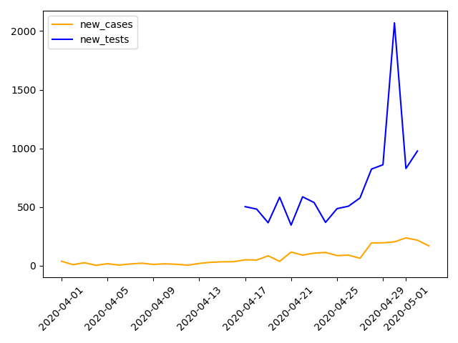

Mobility data reflects no major changes to adherence to NPIs in past two weeks

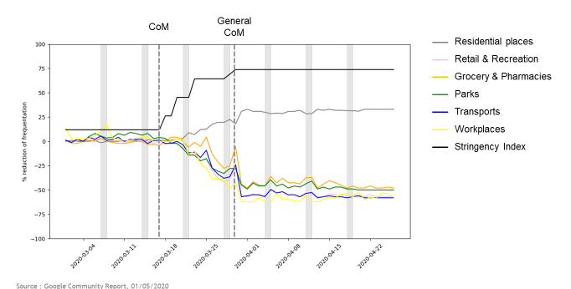

Appendix 2

As of May 3, 2020, NCDC’s categorization of states by outbreak status (e.g., total number of cumulative confirmed cases.)

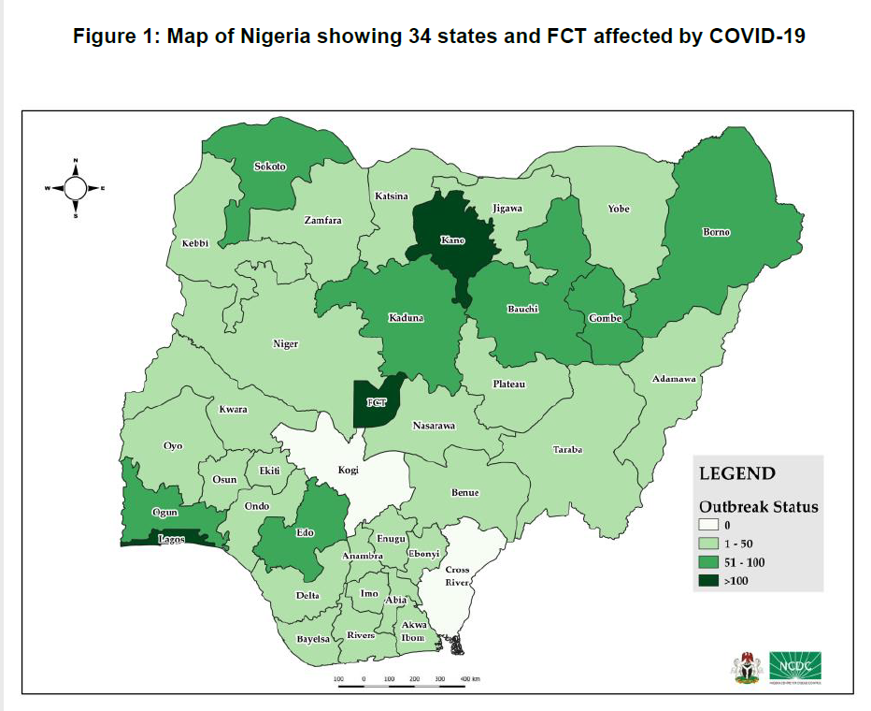

Appendix 3: Evidence Base: Strategies for promoting equity and protecting the vulnerable

Lagos, Kano, and the federal government, for example, have taken some specific measures to protect vulnerable groups:
Vulnerable group | Examples of actions to protect vulnerable groups
Groups with comorbidities or specific healthcare service needs | Lagos: Provision of free medical services for people who presented at the all the secondary health facilities (27 general hospitals) including free access to maternal and child health facilities. The services cover emergencies, casualties, cases including registration, laboratory tests and surgeries for the month of April.
Vulnerable children | Kano: Evacuation of 524 ‘Almajiri’ children to their neighbouring State of origin to fast track their integration into formal school system.
Economically vulnerable | Lagos:  - Food kitchen programme to feed 100,000 people daily, most especially youths.  - Cash transfer to 250,000 indigent citizens who are vulnerable and economically challenged.  - The Governor granted three months moratorium to Micro, Small and Medium Enterprises (MSMEs) and entrepreneurs that got repayable loans from Lagos State Employment Trust Funds (LSETF), deferring the payment of accruing interests by the loan beneficiaries.xxvi  - The Governor granted immediate release of all private and commercial vehicles impounded from March 1, 2020 for minor traffic offences by the police, Lagos State Traffic Management Authority (LASTMA) and Vehicle Inspection Agency to date.xxvi
Kano:
- Distribution of food items and cash to 50,000 households as palliative measures to ease the lockdown measures. Each household is expected to receive a bag of rice, a carton of spaghetti, macaroni, dawavita, four litres of oil and cash gift of N2,000.
Federal Ministry of Humanitarian Affairs, Disaster Management and Social Development:
- Disbursement of N20,000 Conditional Cash Transfer to the poorest and vulnerable households in the country (for four months), who are registered in the National Social Register of Poor and Vulnerable Households set up by the President in 2016 to combat poverty. This was expanded from 2.6 million to 3.6 million.xxix
- Deployment of 77,000 metric tons of food items to vulnerable households of satellite towns in Lagos, FCT and Ogun.
- Central Bank of Nigeria: disbursement of 50 billion Naira targeted credit facility to support households and micro, small and medium enterprises affected by COVID-19.
- The House of Representatives passed the Emergency Economic Stimulus bill 2020 to provide a 50% tax rebate for employers and business owners who agree to not make staff cuts in 2020.

Examples of additional strategies deployed in other countries to support specific vulnerable groups include:
Vulnerable group | Examples of actions to protect vulnerable groups
Groups with comorbidities or specific healthcare service needs | Kenya: Kenya modified its national guidelines to permit all HIV patients to receive antiretroviral treatment for 3-month multi-month dispensing to limit potential exposure of COVID-19 which is already enacted by NCDC.
 | Uzbekistan: Doctors without Borders created tailored campaigns on tuberculosis and COVID-19 for tuberculosis patients and their families in the local language.
India: On April 11th, India laid out a detailed outline on how to enable delivery of essential health services during COVID-19 that relies on separation of ambulances and health care facilities for COVID and non-COVID health services after extending the nationwide coronavirus lockdown. Moreover, India has reclassified health care services into two categories: essential and desirable.
- However, India has suggested adaptations to some essential health care services. While India strongly recommends that reproductive, maternal, new-born, and child services be relatively undisrupted, India’s strategy relies on walk-in appointments for most of these services allowing the possibility for services to be disrupted in practice given fear and lower uptakes of service due to COVID.
Moreover, India’s recommendations for malaria prevention departs from WHO’s guidance, as India suggests that distribution of ITNs and targeted IRS can be postponed until after lockdown.
 | Rwanda: In the early stages of pandemic, Rwanda released a national response plan in line with WHO guidelines to continue HIV, TB, non-communicable diseases, and maternal and child health services. It relies on community health workers (CHWs) playing an essential role in service delivery (e.g. replacing mass distribution of LLINs with door-to-door distribution using CHWs).
Elderly | South Africa: South Africa announced April 26th that elderly workers (e.g., above age of 60) should be given the option to work from home or allowed to remain on full pay.
 | Academic Paper: Scholars recommend those at risk (e.g., elderly and medically vulnerable) to self-isolate by remaining in a designated room within a household, voluntarily swapping households with neighbors, and/or confining in a separate location within a refugee/internally displacement camp.
 | Germany: In the early stages of the pandemic, Germany suspended all visitation of seniors’ private residences, nursing homes, and institutions for people with disabilities. Based on recent study published on May 1st on pandemic spread in Germany, it was found that people of working age group (15-59 years) were more susceptible to COVID-19 than elderly population (people of 60-79 years of age). This could be due to the early restrictions enacted for the elderly population.
Economically vulnerable | India, Kenya, and Rwanda: India, Kenya, Rwanda, and Uganda are developing and expanding digital payment systems to process and deliver direct transfers to individuals.
 | India: Countries like India have announced in-kind transfers (e.g. food and gas) to individuals, similar measures have been enacted by Nigeria.

Appendix 4: NPIs put into action in Lagos, Kano, and FCT
State | Specific measures put in place | State of pandemic progression | Challenges | Additional factors
Lagos | Public gatherings: Ban of public gatherings of more than 50 people including religious congregations.  Markets: Closure of markets that do not sell essential products like food items, pharmaceutical products, water, medical equipment, etc. All restaurants, fast food shops and eateries to serve takeaway to customers with no in-dinning permission. There is closure of shopping malls, and suspension of all street-trading.  Businesses and offices: Closure of all businesses and offices  Schools: Closure of all private and public schools and universities.  Movement restrictions: Imposition of curfew from 8pm – 6am, closure of domestic airport, except flights carrying essential supplies and those on emergency operations, and restrictions of movement in and out of Lagos. | -Average number of new cases daily fluctuates. For example, between 26th April and 3rd May, the number of new cases per day in Lagos are 43, 34, 80, 87, 45, 30, 62 and 39, respectively. Hence, it is difficult to determine the positive effect of and NPI or specific set of NPIs. | Poor basic amenities and lockdown resistance  - Those who live in slums and informal settlement lack water, sanitation, and other basic services. They therefore find it difficult to adhere to regular handwashing due, self-isolate.  - Household congestion with no running water and large sharing of toilets and bathrooms pose difficulty in remaining indoor and allow for easy spread.  -Lockdown resistance have been reported in some overcrowded slums.  - Poor internet connections and lack of reliable electricity make it difficult for people to work remotely.  Poor access to information  -Many informal settlements are cut-off from accurate information flow. This is due to disrupted access to information from radio and television triggered by poor electricity supply.  Difficulty of social distancing  -Difficulty in maintaining 2 metres social distancing in commercial buses due to the overstretched of the current system.x  -Nonadherence to social distancing by street hawkers. | Economic impact  -Loss of wages  -Reduced general consumption of nonessential commodities with impact on the consumption expenditure of owners of these businesses.  -Many private sectors have maintained a ‘no salary during lockdown’ stance or a 50 percent pay cut.  -Increase in layoffs of workers.  -Spike in food prices  Social unrest and crime  -increased armed robberies, fire and small riots in some neighbourhoods.
Kano | Public gathering: Suspension of all public gatherings.  Markets: Closure of all markets, except two markets where vegetables and fruits are sold.,  Borders: Indefinite closure of air land borders and routes linking the state to other parts of the country.  Movement restrictions: Allow free movement between 10am and 4pm on Mondays and Thursdays. | The average number of new cases daily between 28th April and 3rd May are 38, 24, 80, 92, 2 and 29, respectively. No case was reported on April 26th and 27th. | -Non-adherence to lockdown measures due to poor attitude and perception of people on the virus.  -Lack of adherence to prevention protocol during funeral rites. | N/A
FCT | Public gathering: Restriction of public and religious gatherings to a maximum of 50 people.  Markets: Closure of shops in markets and neighbourhood centers to traders across Abuja, except for shops selling essential products and medicines, pharmacies, and bakeries. Reduction of market days to three times in a week- Mondays, Wednesdays and Saturdays, from 7am to 2pm. In addition, only retailers are allowed to operate while wholesale services are not permitted. Residents are to patronise only neighbourhood markets as movement across district is a violation of lockdown. All restaurants, fast food shops and eateries to serve takeaway to customers with no in-dinning permission, except within established hotels where the principle of social distancing will be adopted.  Movement restrictions: Activation of mobile courts to try violators of lockdown directive on CoM. Set up five enforcement teams to ensure compliance of already laid down containment strategies. Businesses can only operate between 6am and 9pm.  Commercial transport: Motorcycle ban in certain areas  Public awareness: Setting up of sensitization efforts in rural communities. | The average number of new cases daily between 26th April and 3rd May are 3, 15, 1, 16, 4, 36, 52, and 12, respectively. The fluctuation makes difficult to determine the positive impact of the measures put in place. | -violations of lockdown directives: residents flouting lockdown directives; traders selling non-essential food commodities opened their shops. | N/A

Appendix 5: Evidence Base: Strategies for Widespread Transmission Phase
Setting | Examples of strategies from academic papers and countries | Current Status of Pandemic
Dense Urban Areas | Academic Paper: An initial analysis of 490 transmission hotspots designated by the government in Mumbai found that 30% were in densely crowded informal settlements, with an additional 20% within 50 meters of a densely crowded informal settlement. Given this high risk, scholars suggest that local coordinated action that includes a governance system, isolation and treatment facilities can be useful to reduce transmission in dense urban areas. | N/A
 | India: Multiple states in India, including Kerala and Odisha, built temporary shelters to ensure safe housing of migrant workers stranded during lockdowns. | While Kerala has incorporated other NPIs in its containment strategy, Kerala has reported two consecutive days of no new COVID-19 cases as of May 4th. Whereas, Odisha reported its highest single-day peak of cases with 17 new cases on April 30th.
 | South Africa: South Africa has provided temporary shelter for the homeless by housing individuals in sports stadiums, schools, and other locked-down public spaces to limit potential spread. | In South Africa, social unrest spurred due to temporary shelter for homeless populations. Individuals feared their chances of contacting the disease are far greater living in the shelter.
Prison and/or congregated settings | Ethiopia: Ethiopia released over 4,000 prisoners to reduce the potential spread within prisons. | While Ethiopia has incorporated other NPIs along with increasing its testing capacity, Ethiopia’s total recovered exceeded its total patients of COVID-19 in treatment centers as of May 4th.
Oil Rigs | Brazil: In late March, Brazil oil company, Petrobras, implemented an additional measure to conduct temperature checks for all workers boarding offshore facilities | Despite its COVID-19 regulations in place, Petrobras recorded over 59 COVID-19 cases and 19 confirmed cases as of April 14th.
Fish landings and fish markets | Academic paper: Ghana, where fish landing sites link to employment of up to 10% of the population, scholars recommended controlling number of boats and personnel allowed at one time, limiting crewmembers per vessel, and deploying fish market-specific public information campaigns with the cooperation of community and NGO leaders. | N/A
Markets | Ethiopia: Atikilit Tera market in Addis Ababa was relocated to a more open outdoor space | While Ethiopia has incorporated other NPIs along with increasing its testing capacity, Ethiopia’s total recovered exceeded its total patients of COVID-19 in treatment centers as of May 4th.
 | Rwanda: Markets will reopen post-shutdown, but only for essential vendors and capacity will be limited to 50% of registered traders only announced April 30th | N/A
 | India: In Andhra Pradesh, even in outdoor markets, official markings on the ground indicate where shoppers are allowed to stand to ensure proper distancing. | Witnesses have reported crowded markets despite enacted regulations.
 | Vietnam: Authorities use “quick-result tests” to screen sellers at wholesale markets to ensure safety | Through its aggressive mass testing and implementation of several NPIs, Vietnam claims to have contained COVID-19.

Appendix 6: Evidence Base: Strategies for Localized Community Transmission

Setting | Examples of strategies from academic papers and countries | Status of Pandemic
Cluster | India: Odisha took early action to identify and isolate high-risk districts, locking down 5 high risk districts within a week of the first case in their state. | Ultimately, however, Odisha opted to move to a state-wide lockdown prior to India’s national lockdown.
 | India: Maharashtra’s capital city, Mumbai, deployed over 490 containment zones in its key urban areas. | As of April 28, Maharashtra had more cases than any other state in India.
Rural Areas | Academic Paper: Recruit community leaders (e.g., village or religious leaders, traditional healers, youth leaders) to deploy rural-specific public information campaigns | N/A
 | Academic Paper: Develop contact tracing strategies focused on understanding reverse migration movement from urban to rural areas | N/A

Appendix 7: Evidence Base: Strategies for Containment/Transition

Country | Examples of strategies from academic papers and countries | Status of Pandemic
India | In the early phase of the pandemic, Kerala deployed extensive testing and contact tracing, including publishing route maps of infected persons to help identify potential contacts. Contacts were put in self-isolation, and state officers were deployed to go door-to-door to enforce quarantines. | While Kerala has incorporated other NPIs in its containment strategy, Kerala has report two consecutive days of no new COVID-19 cases as of May 4th.
Ethiopia | 40,000 community health workers performed door-to-door health checks at over 3 million homes, and rapid response teams verify all rumored cases reported through regional hotlines, points of entry, and hospital / health care facilities. Once confirmed, all identified contacts of symptomatic case within 14 day window are examined to determine if symptoms are present. | While Ethiopia has incorporated other NPIs along with increasing its testing capacity, Ethiopia’s total recovered exceeded its total patients of COVID-19 in treatment centers as of May 4th.

Appendix 8: Assumptions for estimating number of critical cases based on SEIR model outputs
To estimate the percentage of critical cases in Nigeria, we combined Nigeria’s age pyramid to statistics of criticality by age for COVID. This leads to an average 6.8% of critical cases. Then, to estimate the daily capacity needed for critical cases, we assume that a case becomes critical 7 days⁸² after detection and that the length of stay in critical care is 15 days⁸³.

Appendix 9: Impact of COVID-19 on other causes of morbidity and mortality
- Malaria: Nigeria has approximately ¼ of the world’s malaria morbidity and mortality, and key interventions include insecticide-treated nets, case management, and seasonal malaria chemoprevention in selected states. Six states are scheduled for 2020 net distributions; the status of these campaigns in the wake of COVID-19 is unknown. Modeling the effect of disruptions to net campaigns and access to antimalarials (report) has shown that if the net campaigns do not occur and routine net distributions are disrupted, increases in cases and deaths of ~4% are expected. If access to antimalarials is disrupted, deaths could increase by 29-101%, with as many as 100,000 additional malaria deaths in 2020 under a worst-case scenario. Modeling of mitigation strategies is expected to begin this week, under the WHO High Burden, High Impact initiative.
Data: Hannah Slater (PATH), Pete Gething, Amelia Bertozzi-Villa, Sam Bhatt, Dan Weiss (Malaria Atlas Project)
The graph on the left shows malaria incidence month-by-month in 2020, with transmission intensity increasing over the summer and peaking in early autumn.
This graph shows the proportion of Nigeria’s 2020 malaria incidence expected to overlap with COVID-19-related disruptions to the healthcare system. 12 different disruptions are modeled: durations of 3, 4, 5, 6, 7, & 8 months’ length, starting on April 1 (first 6 columns) or May 1 (last 6 columns).

Under a scenario with disruptions beginning May 1 and lasting six months (starred bar), 80% of the country’s malaria cases could occur in the period of COVID-19-related service disruptions; if essential malaria services such as case management are reduced, the impact could be profound.

© Bill & Melinda Gates Foundation |
3
In scenario 2, we assume increased disruptions to health systems due to workforce and supply chain issues related to the pandemic response. Some health workers are diverted to COVID-19 activities, while others become sick or are overwhelmed.
Workforce shortages have a greater effect on interventions requiring skilled care. Interventions that are less dependent on skilled health workers are less affected.
Global supply chains remain open for most RMNCH commodities. However, domestic supply chains are disrupted due to local bottlenecks, resulting in the reduced availability of hormonal contraceptives, antenatal supplementation and malaria prevention, commodities for childbirth
- Maternal and Child Health: The John Hopkins University team used three scenarios using the Lives Saved Tool (LiST) in which coverage of basic life-saving interventions is reduced to different extents (10% to 50%) and for different durations (3, 6, and 12 months), using assumptions based on emerging reports of the supply-side and demand-side effects of the pandemic to model maternal and under-five child mortality for each scenario in 118 low- and middle-income countries. In Nigeria, taking a 6 month time period, due to reductions in coverage of key interventions, under scenario 1, there will be an increase of 1.8K maternal deaths and 40K U5 child deaths; under scenario 2, there will be an increase of around 3K maternal deaths and 70K U5 child U5 deaths, and under scenario 3, there will be an increase of around 7K maternal deaths and 173K U5 child deaths. For maternal mortality, under the most extreme scenario (scenario 3) at 6 months, reductions in parenteral administration of uterotonics and anti-convulsants, reductions in contraceptive use and MgSO4 management of pre-eclampsia and lack of clean birth environment will contribute to 69% of the additional maternal deaths. For U5 child mortality, changes in wasting prevalence, reductions in administration of oral antibiotics for pneumonia, ORS, and case management of neonatal sepsis/pneumonia will contribute to 77% of the additional U5 child deaths.
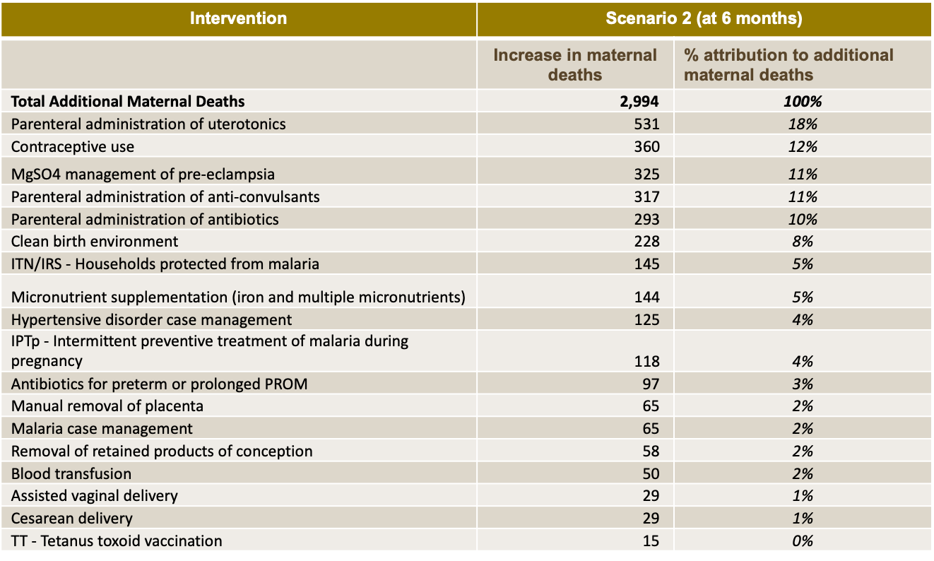

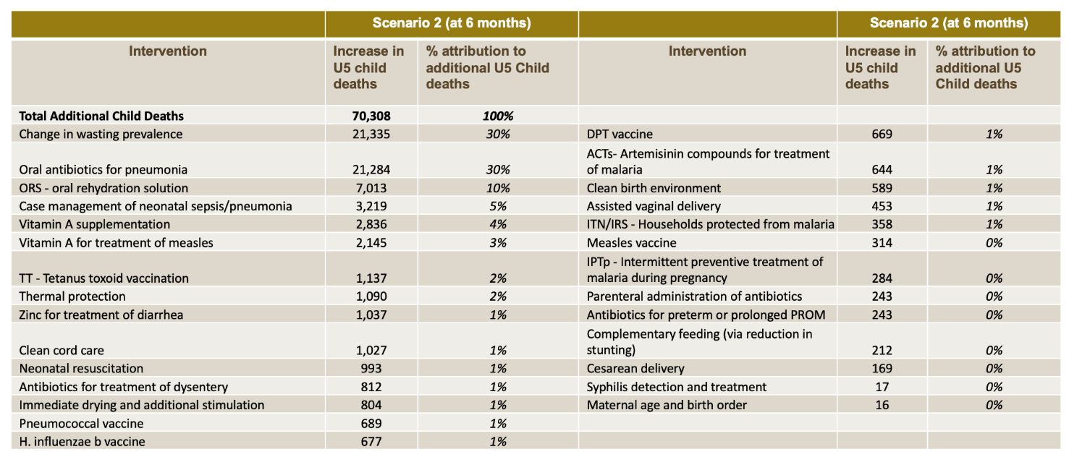
Immunisation: An analysis by LSHTM assessed the risk/benefit trade-off of routine immunization (RI) in the context of COVID-19. An RI visit comes with a risk of increased COVID-19 transmission and resulting COVID-19 deaths; however it also confers benefits in terms of protection from vaccine preventable diseases (VPDs). Modeling for Nigeria shows that for every excess COVID-19 death attributable to transmission originating from an RI visit, there would be 116 (CI: 32-423) VPD deaths prevented (report). Specifically, over a 6-month period in Nigeria, continuation of RI services would be projected to cause 800 excess COVID-19 deaths, while preventing 92,474 future U-5 deaths from VPDs such as measles, pertussis, and more. Luckily, many excess deaths from reduced RI would occur >1 year in the future and could be mitigated by catch-up activities. Still, even assuming perfect catch-up would occur, the benefits of sustaining RI outweigh the risks several times over.
Polio: COVID-19 has resulted in delays and cancellation of planned bivalent OPV campaigns and monovalent OPV2 outbreak response activities. IDM and Imperial College London have developed polio immunity estimates of the impact of these disruptions on polio immunity and are developing geospatial risk models to forecast of cVDPV2 outbreak expansion within the country.

The analysis in this paper is purely the work of the Nigeria COVID-19 evidence synthesis group* for use by the PTF. Unauthorized use or publication of this material without the permission of the PTF is prohibited.
* The Nigeria COVID-19 evidence synthesis group is chaired by Prof Ibrahim Abubakar, scientific and technical advisor to the PTF.

References

On April 22, the average number of daily tests over the previous five days was 457. On May 4, the average daily tests over the previous five days was 892. This excludes April 30, on which 2,070 new tests were reported.
Countries have taken different approached to supporting business continuity. For example, China provided subsidies for small businesses that sign long-term employment contracts with college graduates to help stimulate the workforce and has urged companies to adopt innovative recruiting methods like online registrations and phone/video interviews to reduce in-person contact. (The Star, “China moves to stabilise employment amid COVID-19 epidemic,” March 9, 2020.) Italy has launched a digital solidarity site, which provides promotions for all businesses especially SMEs and self-employed persons e.g. tech companies providing access to cloud computing services, offering online meeting services, etc. (https://solidarietadigitale.agid.gov.it/#/) Prior to its reopening, New Zealand allocated ~$100M to help with employee training to work in industries not impacted by COVID-19. (Ireland Hendry-Tennent, “Coronavirus: Government announces $100M forestry redeployment package for Gisborne,” Newshub, March 20, 2020)
“COVID-19 Situation Report,” NCDC,4/1/2020 through 5/3/2020
“COVID-19 Situation Report,” NCDC, 4/28/2020
Channels Television. Lockdown: Lagos Govt announces free medical services for pregnant women, people with health emergencies. Channels Television, April 4, 2020.
Vanguard News Nigeria. COVID-19: Kano evacuates 524 Almajiri children to Jigawa. Vanguard, April 22, 2020.
Plustv. Lagos State Governor, Sanwo-olu reels out coping measures in place to help with lockdown including food kitchen, others. Plustv. April 15, 2020.
Kunle Awosiyan. COVID-19.: Lagos State Govt to Transfer cash to the indigent, feed 100,000 youths daily. STV.
Abdulmumin Murtala. COVID-19: 50,000 poor households get palliative in Kano. Vaunguard, April 23, 2020.
Dennis Erezi. Nigeria government begins distribution of N20,000 relief fund to homes. The Guardian, April 01, 2020.
Victoria Onehi. COVID-19: Nigerian government to feed pupils at home. Daily Trust, April 8, 2020.
Human Rights Watch. Nigeria: Protect most vulnerable in COVID-19 response. Human Rights Watch, March 26, 2020.
“Differentiated Service Delivery and COVID-19,” Columbia University, 4/7/2020
“Coronavirus - Africa: Racing to respond to the COVID-19 pandemic in over 70 countries,” AfricaNews, 4/23/2020
Ministry of Health and Family Welfare, “Enabling Delivery of Essential Health Services during the COVID 19 Outbreak: Guidance Note,” Government of India, April 14, 2020, https://www.mohfw.gov.in/pdf/EssentialservicesduringCOVID19updated0411201.pdf; “India decides to extend nationwide Coronavirus lockdown – State Chief Minister,” U.S. News, 4/11/2020
Rwanda ministry of Health, “Coronavirus Disease 2019, National Preparedness and Response Plan,” Republic of Rwanda, March-August 2020, https://www.rbc.gov.rw/fileadmin/user_upload/annoucement/Coronavirus%20Disease%202019,%20National%20Preparedness%20and%20Response%20Plan.pdf.
Rwanda ministry of Health, “Coronavirus Disease 2019, National Preparedness and Response Plan,” Republic of Rwanda, March-August 2020, https://www.rbc.gov.rw/fileadmin/user_upload/annoucement/Coronavirus%20Disease%202019,%20National%20Preparedness%20and%20Response%20Plan.pdf.
“Progress on COVID-19: South Africa Public Health Response,” Minister of Health of South Africa, 4/26/2020
“COVID-19 control in low-income settings and displaced populations: what can realistically be done?” London School of Hygiene & Tropical Medicine, 3/20/2020; “COVID-19 Projecting the impact in Rohingya refugee camps and beyond,” John Hopkins Bloomberg School of Public Health, 3/27/2020
“Germany’s COVID-Story,” City Journal, 4/28/2020
“COVID-19 trends from Germany show different impacts by gender and age,” Brookings Institution, 5/1/2020
IMF, “World Economic Outlook - Chapter 1: the Great Lockdown,” April 2020.
IMF, “World Economic Outlook - Chapter 1: the Great Lockdown,” April 2020.
Nan. Lagos state bans religious gatherings above 50 persons. The Guardian, March 18, 2020.
David Royal. Lagos government orders closure of markets. Vanguard, March 25, 2020.
Chike Olisah. Lagos State to shut down markets. Coronavirus, March 24,2020.
Oluwatobi Bolashodun. Lagos State orders closure of private and public schools over coronavirus. Legit.ng, March 19, 2020.
Titobioluwa Okuande. COVID-19: Lagos state to begin curfew on Sunday to disinfect metropolis. Business News, March 28, 2020.
NCDC. An update COVID-19 outbreak in Nigeria.
Taibat Lawanson. Lagos’ size and slums will make stopping the spread of COVID-19 a tough task. The Conversation, April 1, 2020.
Ndukka Orjinmo. Lagos lockdown over coronavirus: How will my children survive. BBC News, March 31, 2020.
Oke Ogunde. The impact on Nigeria of the coronavirus pandemic: socioeconomic pandemonium! In Defence of Marxism, April 14, 2020.
Libby George. Nigeria to extend coronavirus lockdowns for more 14 days: President Buhari. World News, April 13, 2020.
Oke Ogunde. The impact on Nigeria of the coronavirus pandemic: socioeconomic pandemonium! In Defence of Marxism, April 14, 2020.
Shehu Isah Daiyanu Dumus. Millions face hunger as African cities impose coronavirus lockdowns. The Economic Times, April 16, 2020.
NAN. Kano suspends official gatherings, directs closure of event centres. The Nation Newspaper. March 23, 2020.
Garba Muhammad. Nigeria’s northern economic hub Kano imposes week-long lockdown over coronavirus. Nasdaq, April 14, 2020.
Abdur Rahman Alfa Shaban. Nigeria coronavirus: Lockdown relaxation starts, Kano deaths virus-related. Africanews, May 4, 2020.
NAN. COVID-19: Kano government orders closure of land borders. The Guardian, March 26, 2020.
Abdur Rahman Alfa Shaban. Nigeria coronavirus: Lockdown relaxation starts, Kano deaths virus-related. Africanews, May 4, 2020.
NCDC. An update COVID-19 outbreak in Nigeria.
News Agency of Nigeria. Coronavirus: PTF cautions Kano residents on social distancing. Pulse Nigeria, May 4, 2020.
Ebuka Onyeji. FCT bans religious, public gatherings of over 50 persons. Coronavirus, March 21, 2020.
Seun Opejobi. COVID-19: FCT Minister orders closure of markets, neighbourhood centers in Abuja over coronavirus. Daily Nigeria Post, March 25, 2020.
Fikayo Olowolagba. COVID-19: FCT Minister announces days markets will be opened in Abuja. Daily Nigeria Post, April 6, 2020.
Don Silas. Coronavirus: FCT Minister reveals new measures to control spread of COVID-19. Daily Nigeria Post, March 27, 2020.
John Owen Nwachukwu. COVID-19: FCTA releases new guidelines on lockdown in Abuja, bans okada. Daily Nigeria Post, April 16, 2020.
John Owen Nwachukwu. COVID-19: FCTA releases new guidelines on lockdown in Abuja, bans okada. Daily Nigeria Post, April 16, 2020.
NCDC. An update COVID-19 outbreak in Nigeria.
Anthony Ogunleye. Nigeria: Coronavirus-Abuja Govt condems violation of lockdown, issues new directives on markets, okada. Premium Times, April 15, 2020.
Patranabis, et al. “Are slums more vulnerable to the COVID-19 pandemic: Evidence from Mumbai,” Brookings Institution, 4/16/2020
Taruka Srivastav “Why India has the upper hand against COVID-19,” World Economic Forum, 4/17/2020
“Kerala records second consecutive day with no new COVID-19 cases, 61 recover,” Onmanorama, 5/4/2020
“Odisha records highest single-day spike in COVID-19 cases; 17 news cases from Jajpur,” India Today, 4/30/2020
“Mixed blessing for some, as South Africa shelters homeless in schools, stadiums, Reuters, 4/16/2020
“Mixed blessing for some, as South Africa shelters homeless in schools, stadiums, Reuters, 4/16/2020
“Ethiopia pardons more than 4,000 prisoners to help prevent coronavirus spread,” CNN, 3/27/2020
“Notification Note on COVID-19 Situational Update,” Ethiopian Public Health Institute, 5/4/2020
“Petrobras details measures to safeguard staff in Brazil,” Offshore, 3/24/2020
“Exclusive: Brazil battles dozens of coronavirus cases on offshore oil rigs, Reuters, 4/14/2020
“Impact COVID-19 on Fishing and Coastal Communities in Ghana and Globally”, University of Rhode Island, 4/2/2020
Abdur Rahman Alfa Shaban, “Ethiopia coronavirus cases at 117, Tigray relaxes state of emergency,” 4/24/2020
“Notification Note on COVID-19 Situational Update,” Ethiopian Public Health Institute, 5/4/2020
Republic of Rwanda Office of the Prime Minister, “Statement on Cabinet Resolutions of 30th April 2020,” 4/30/2020
Raya Ghosh, “Coronavirus: Squares drawn at vegetable markets in Andhra Pradesh to ensure social distancing,” India Today, 3/26/2020; “Coronavirus: Is social distancing an oxymoron in India?” BBC News, 4/24/2020
“Coronavirus: Is social distancing an oxymoron in India?” BBC News, 4/24/2020
Dezan Shira, “Vietnam Business Operations and the Coronavirus: Update,” Vietnam Briefing, 4/30/2020
“Insight-After aggressive mass testing, Vietnam says it contains coronavirus outbreak, Nasdaq, 4/30/2020
Taruka Srivastav “Why India has the upper hand against COVID-19,” World Economic Forum, 4/17/2020
Surendra P Gangan, “In Maharashtra’s Covid-19 containment plan, Mumbai, Nagpur and Pune are key,” Hindustan Times, 4/6/2020.
“India's Covid-19 cases near 30,000. Check how your state is doing,” India Today 4/28/2020
Peter Ranscombe, “Rural areas at risk during COVID-19 pandemic,” The Lancet, 4/17/2020
Ibid.
Taruka Srivastav “Why India has the upper hand against COVID-19,” World Economic Forum, 4/17/2020
“Kerala records second consecutive day with no new COVID-19 cases, 61 recover,” Onmanorama, 5/4/2020
“Covid-19 checks cover over 3 million Ethiopian homes,” APA News 4/25/2020; “National Comprehensive COVID-19 Management Handbook,” Ethiopia Public Health Institute, 4/2020
“Notification Note on COVID-19 Situational Update,” Ethiopian Public Health Institute, 5/4/2020
Age Pyramid of Nigeria, https://www.populationpyramid.net/nigeria/2019/
“Report 9: Impact of non-pharmaceutical interventions (NPIs) to reduce COVID-19 mortality and healthcare demand”, Imperial College, 3/16/2020 82 “Estimating the burden of SARS-CoV-2 in France”, Pasteur Institute, 4/20/2020 83 “Clinical Characteristics of Coronavirus Disease 2019 in China”, Guan WJ & al., 2/28/2020

