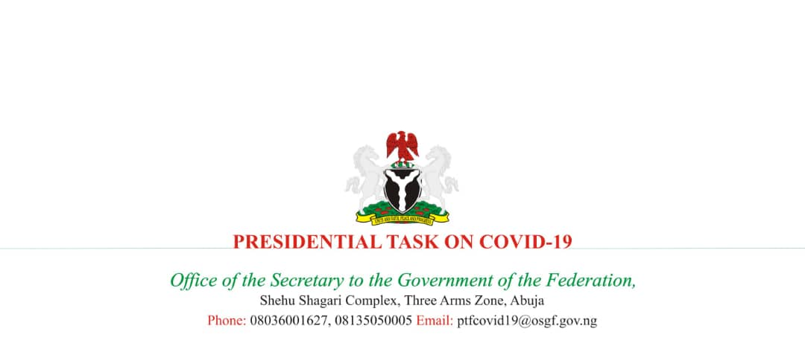

IMPLEMENTATION GUIDANCE FOR LOCKDOWN POLICY
Section I: Guidance for Lockdown Enforcement
As part of the measures in place to enforce social distancing and limit the spread of the SARS-CoV-2, the Federal Government of Nigeria has decided that schools, organizations and businesses in FCT, Lagos and Ogun States will close effective from 30 March 2020 at 23:00h for an initial period of 2 weeks.
- For the period of the lockdown, every person is confined to his or her place of residence, unless strictly for the purpose of performing an essential service, obtaining an essential good or service, or seeking medical care.
- All borders linking the two States and FCT to the rest of the country are shut during the period of the lockdown, except for the transportation of persons on essential duty, food, fuel, manufactured goods or donated relief items. Security agencies should note this.
- Mass gathering is prohibited, except for funeral services as guided by infection prevention and control regulations, for which social distancing rules apply and crowds are limited to not more than 20 persons.
- Movement between and within the affected States and FCT is restricted, except for workers involved in the delivery of authorized essential services, duties, food and goods.
- Retail shops and malls must be closed, except where essential goods are sold. Shops and malls that are open must enforce social distancing and hygiene measures in line with issued guidelines.
- Any business or organization providing essential goods and services must identify the staff who will perform those services.
- Commuter services between cities and States including passenger rail services, bus services, e-hailing services, maritime and air passenger transport are suspended for the period of the lockdown in the affected States.
  - Limited transport services are allowed for the movement of workers, services and goods in response to COVID-19 and for the purpose of seeking medical attention or provision of essential services. Transport services available during the lockdown must implement social distancing and hygiene measures. The table below lists the essential services and businesses that are exempted:

Services and Businesses | Exemptions
Medical | - Private and public hospitals  - Dental clinics (emergencies only)  - Specialist Clinics  - Pharmacies and chemist shops  - Opticians and ophthalmologists (emergencies only)
Retail : All should ensure social distancing and increased hygiene measures are in place | - Food markets, open from 10:00h -14:00h daily)  - Supermarkets and shops selling food and essential non-food items (groceries)  - Shopping malls (only shops selling food and essential groceries shall open)
Food and drink | - Food delivery services (no eating-in)
Logistics and transportation | - Fuel stations  - Registered repair garages  - Company car services for essential staff  - Post offices  - Courier and distribution companies  - Private security companies  - Trucks carrying essential goods including food, pharmaceuticals and manufactured goods related to the COVID-19 response  - Airline ground handling staff and essential aviation staff
Accommodation | - Hotels with guests and/or hosting essential staff (no restaurants, bar services or night clubs shall open to the public)  - Orphanages and homes
Financial institutions | - Banks: skeletal services to maintain ATMs, essential online operations and cash services.
Government institutions and public utilities | - Agencies involved in essential duties (see list below)  - Utility companies  - Electricity distribution and Transmission company  - Waterboards  - Waste management  - Environmental Health Services  - Telecommunications
Places of worship | - Small funeral services limited to 20 persons only
Agriculture | - Farms, distributors of food and perishable commodities
Manufacturing | - Manufacturers of food, drugs, pharmaceuticals and essential products related to the response
Aviation | - Cargo and specially approved flights only
Communications | - Telecommunication companies, newspaper, TV, radio and broadcasting companies  - Workers allied to this sector including newspaper vendors  - Internet service providers
Legal and Security | - Public and private security agencies  - Criminal justice and correctional services as necessary to maintain law and order
Diplomatic Missions, International development partners and honorary consulates | - Critical diplomatic staff necessary for essential embassy functions including security, consular issues, plant maintenance etc.

SECTION II: PROTOCOLS FOR LOCKDOWN
ROAD MOVEMENTS
- With regards to the carriage of passengers:
- Ensure adequate spacing in between passengers
- Clean and disinfect frequently touched parts e.g. door and window handles/buttons, steering wheels and dashboards.
- Encourage passengers to frequently perform hand hygiene.

SUPER MARKETS AND FOOD STORES
- All owners and managers of supermarkets and food stores must strictly adhere to the following:
- On arrival, all staff must be screened for high temperature. Those found to have a body temperature above 38.0⁰C should be denied entry and advised to immediately seek medical attention.
- Ensure staff and customers wash their hands before entry to the store. Make provision for regular hand hygiene for staff during working hours.
- Ensure all deliveries of supplies and products are made between 5:00 am and 9:00 am. Porters should wash their hands before offloading products and goods.
- Store opening hours should be between 10am to 4pm daily for customers
- At any point in time, the total number of customers inside each store must not on average exceed a third of the store’s maximum capacity. Where necessary, store owners should assign security personnel to ensure strict compliance with these measures.
- Ensure that from 4pm all shelves, aisles and stores are cleaned and disinfected
- Ensure that by 6pm, all stores are closed, and staff conveyed back to their respective homes.

PHARMACIES
- The rules above for supermarkets shall also apply to pharmacies. However, 24-hour pharmacies may continue to operate as usual.

MARKETS
In order for markets to operate, State and local government authorities as well as leaders of market associations must take full responsibility for strict compliance with the following protocols:
- Only shops and stalls selling food and groceries shall be allowed to open to customers between 10:00am to 2:00pm every 48 hours or less frequently.
- All market associations must make provision for hand washing for all sellers and buyers. At entry and exit points of the market, both sellers and buyers must wash or sanitize their hands.
- Each stall/shop in the market should ensure that their customers queue and are attended to serially while complying with social distancing measures and avoiding overcrowding.
- All shop owners and staff must arrive and set up at least 30 minutes before the market is open to customers. Each store owner is responsible for cleaning and disinfecting their shops.
- All markets should strictly comply with social distancing policies. A safe gap should be ensured between shop/stall owners and customers.

BANKS
- All banks shall comply with the guidelines, mode and scope of operations issues by the Central Bank and Federal Ministry of Finance as it related to the COVID-19 response.
- All banks shall make provision for hand hygiene at the entry of the premises and temperature monitoring of all staff and customers.
- Those customers and staff found to have a body temperature above 38.0⁰C shall be denied entry and advised to immediately seek medical attention.
- Banks should develop a schedule for cleaning buttons and surfaces of ATM machines.

LIST OF EXEMPTED GOVERNMENT AGENCIES
Due to the essential nature of their functions, the following MDAs are exempted from the lockdown order (this list is not exhaustive):
- The Presidency
- Office of the Secretary to the Government of the Federation
- Federal Road Safety Corps
- Bureau of Public Procurement
- National Agency for the Control of AIDS
- Offices of all permanent secretaries, CEOs/accounting officers of all MDAs in the public service
- Department of State Services
- Central Bank of Nigeria
- Federal Ministry of Agriculture
  - National Grain Reserves
- Federal Ministry of Aviation
  - Accident Aviation Bureau
  - Federal Airports Authority of Nigeria
  - Nigerian Airspace Management Agency
  - Nigeria Civil Aviation Authority
  - Nigerian Meteorological Agency
- Federal Ministry of Communications
  - Galaxy Backbone
  - Nigeria Communications Commission
  - Nigeria Information Technology Development Agency
- Federal Ministry of Environment
- Federal Ministry of Finance, Budget and National Planning
  - Nigeria Customs Service
  - Nigerian Sovereign Investment Authority
  - Debt Management Office
- Federal Ministry of Health
  - All teaching hospitals and federal medical centres
  - Nigeria Centre for Disease Control
  - National Primary Healthcare Agency
  - National Health Insurance Scheme
  - Nigerian Institute of Medical Research
- Federal Ministry of Humanitarian Affairs, Disaster Management and Social Development
  - National Agency for Prohibition of Trafficking in Persons
  - National Emergency Management Agency
  - National Cash Transfer Office
  - National Commission for Refugees, Migrants and Internally Displaced Persons
  - National School Feeding Programme
- Federal Ministry of Information and Culture
  - Federal Radio Corporation of Nigeria
  - National Orientation Agency
  - News Agency of Nigeria
  - Nigeria Broadcasting Commission
  - Nigeria Television Authority
  - Voice of Nigeria
- Federal Ministry of Interior
- Federal Fire Service
- Nigeria Immigration Services
- Nigerian Correctional Services
- Nigerian Security and Civil Defence Corps
- Federal Ministry of Justice
- Federal Ministry of Petroluem
  - Nigeria National Petroleum Corporation and allied petroleum sector agencies
  - Upstream oil and gas companies (operating, services and logistics)
- Federal Ministry of Transport
  - Nigerian Ports Authority
- Federal Ministry of Industry, Trade and Investment
- Federal Ministry of Water Resources
- The Armed Forces
- The Nigeria Police Force

